**Biol 234 Vertebrate Biology**

**Dr, Ryan**

**Reproductive Strategies in Metatherians and Eutherians**

Reproduction is of primary importance to all life. Of all vertebrates, mammalian reproductive patterns depart most from the primitive ancestral condition of laying eggs. Indeed, living monotreme mammals retain the amniotic egg of their ancestors, but the eggs contain less yolk than those of similarly sized reptiles or birds. Monotremes also retain other “reptilian” characters such as an egg tooth and a leathery eggshell. In contrast to reptiles and birds, after they hatch newborn monotremes are nourished by milky secretions produced by their mother’s mammary glands.

In living metatherians (marsupials), a very thin and highly permeable shell membrane is present in the uterus prior to birth. This allows the embryo to receive nourishment from the mother’s uterus during gestation. Later, selection favored characteristics that increased the *in utero* embryonic period known as gestation. Such traits, including modification of embryonic membranes to form a placenta, are hallmarks of eutherian mammals (i.e. placental mammals).

In eutherians, nourishment and protection for the fetus are provided by the mother and usually fetal survival rates are high. All mammals nourish their young with milk after birth, but the relative investment in lactation varies widely among mammal groups.

Let’s use **Quaardvark** to look at the different reproductive strategies of different mammal lineages.

Research Question: Do different lineages of mammals invest differently in gestation versus lactation?

**Example search:**

Let’s compare reproductive patterns in two very different mammalian lineages; metatherians vs. eutherians.

Begin by setting up the following query in Quaardvark:

Edit the **Animal Group** to read **Metatheria** and click Save.

Click the green **Submit** button in the lower right hand corner.

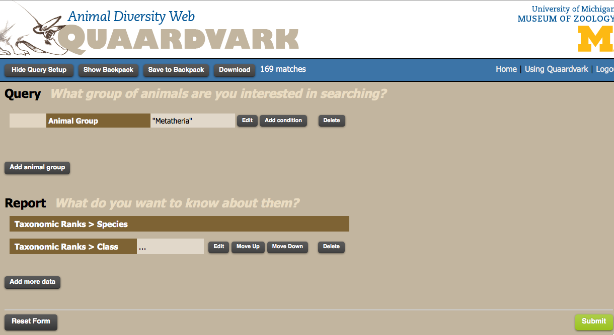

A report appears listing the metatherian species in the database.

**Q: How many metatherian species are listed?**

Click the **Show Query Setup** in the upper left hand corner to go back to your query page. Repeat this procedure for Eutherians and record the total number in the database.

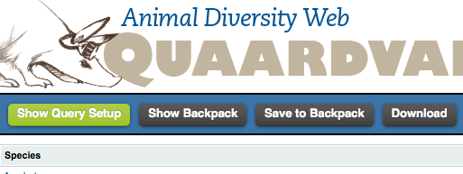

You now have a feel for the size of the database for mammals. Next, we’ll begin the analysis of reproduction.

Click the **Add Condition** button next to your Metatheria entry. A large drop down list appears. Explore this list by clicking on one of the titles in the list. For example, click on **Habitat** or **Reproduction** to see what types of data are available there.

When you are finished exploring, click on the **Physical Description** title. Select **Mass** and then under the word Mass to the right select “less than” and enter **10** in the box. Change the units to **Kg** and then click the **Save Changes** button. (see below)

**Q: Explain what this step accomplishes.**

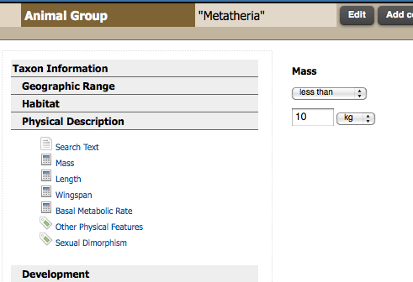

**Return to the main query page by clicking the Show Query Setup** button again.

Click on the **Add Animal Group** button. Enter the group **Eutheria** in the box and click **Save**. Click the **Add Condition** button next to you Eutheria entry. Click on the **Physical Description** title again and select **Mass**. Under the word Mass to the right, select “less than” and enter **10** in the box. Change the units to **Kg** and then click the **Save Changes** button.

Your query should now look like the one shown below:

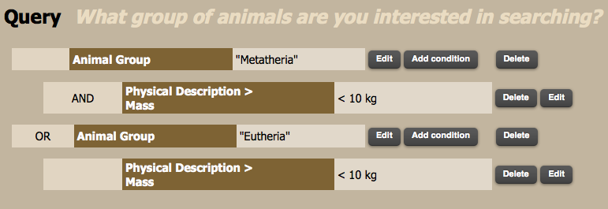

You now need to figure out what to report. You will now focus on the **Report** section.

Before you begin, however, you should answer the following questions:

**Q: Can you think of a measure that is reported by Quaardvark that can be used as a surrogate for lactation period?**

**Q: What mammalian lineages are most likely to reveal differences in reproduction?**

**Q: What other aspects of reproduction or natural history might reveal interesting patterns?**



Click the **Add More Data** button.

Under Taxonomic Ranks click on **Order** and **OK**.

Click the **Reproduction: General Behavior** title from the list.

Click on **Gestation period**. In the column to the right enter **Days** as the units and leave the remaining boxes checked. Click **OK**.

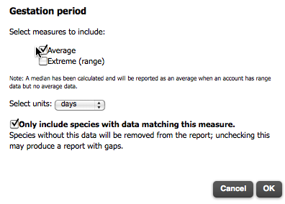

Back in the Report screen, click **Add More Data** button again.

Click the **Reproduction: General Behavior** title from the list.

**Q: What data from the list is the best surrogate for lactation period?**

Answer: Time to weaning is essentially the same as lactation period so we’ll use that data.

Click on **Time to weaning** and enter **Days** as the units and click **OK**.

Click on the green **Submit** button to generate the report. Be patient as it may take sometime to load all the data.

The data you requested appears in a table with columns for species name, family, gestation period (days), and time to weaning (days). Save this data to your backpack. Download the data to you computer so that you can open it in Excel.

Open the data is Excel. A small portion of the data is shown below.

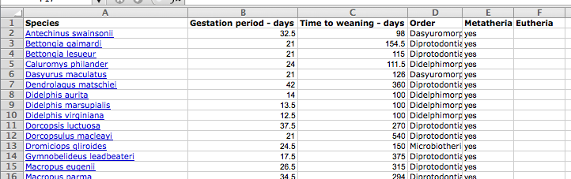

Use the order name to search for all the metatherians. You may want to consult your textbook or visit Animal Diversity Web (ADW) for help:

<http://animaldiversity.ummz.umich.edu/site/accounts/classification/Metatheria.html#Metatheria>

There are 7 orders listed in ADW but you do not have data for all of them.

First, create a new column labeled **Metatheria**. For each entry that is a metatherian, type **YES** in the Metatheria column. Then sort that column so the yes labels all appear at the top of the page. (See above).

In the Excel menu bar, click **Edit** > **Move or Copy Sheet**. In the pop up box, click the “**Create a copy**” box and select “(**move to end**)” from the list, then click **OK**. This creates a duplicate spreadsheet that you can edit. Repeat this so that you have two copies of your data.

Working in one of the two new (copied) sheets, select all the Metatherians and delete them from the spreadsheet. Save this sheet as Eutherians. Go to the other copy and delete all the Eutherian data. Name this sheet Metatheria.

**Q: What are the means, std. deviations, and std. errors for gestation and time to weaning for each group (Metatherians and Eutherians)?.**

In an empty spot on one of the sheets, set up a small table with the mean and std. error data.

|  |  |  |
| --- | --- | --- |
|  | Metatherian | Eutherian |
| Mean Gestation | 23.2 | 89 |
| Mean Lactation | 187.6 | 92 |

**Q: What does the mean gestation and lactation period look like graphically?**

Graph these means using a histogram. It should look similar to the one below:

**Q: How might you interpret this graph?**

Next, go back to the Excel spreadsheet.

Sort by gestation period, for each group from lowest to highest. Answer the following questions:

**Q: Which of the metatherians have the longest gestation?**

Note: you can click on the species name to go to the ADW account to learn more.

**Q: Which subgroup of metatherians have the longest gestation period?**

**Q: What do you know about these species natural history?**

**Q: How would your results change if this group were removed?**

**Q: What do you predict would happen if you had not restricted your search to species weighing less than 10 Kg?**

**Your project:**

1. Predict a different relationship between two of the reproductive variables listed in **Reproduction: General Behavior**. You may use gestation period or time to weaning again, but not both.
2. Graph the relationship in Excel as a histogram. Explain the trends you see.
3. Prepare a 5-minute powerpoint to explain what you compared, what you expected, and what you found, as described above.

**_________________________________________________________________________________________________________**

**Create a Bar Graph Using Excel**

1. Open Excel. Locate and open the spreadsheet from which you want to make a bar chart.
2. Select all the data that you want included in the bar chart.
3. Click the **Chart Wizard** toolbar button, or choose **Chart** from the **Insert** menu.
4. Make sure that **Column** is selected under **Chart type** (it's the default setting).
5. Select a subtype of bar graph from the display on the right, and click **Next**.
6. Make sure that the data range is correct. Click on **Chart Layout** from the menu ribbon.
7. Enter the titles of the chart for the X axis and Y axis. These titles will appear in the appropriate places on the bar graph.
8. Click the other tabs and make any changes you want. For example, you can add error bars by clicking on **Error Bars**.
9. Decide where to place the bar chart. It can be placed on a separate sheet or it can be embedded in the spreadsheet.
10. Click **Finish**. You've just made a bar graph in Excel.
11. Use the **Chart** toolbar to make any final adjustments on the bar graph. If the toolbar isn't visible, select **View**. Select the **Toolbars** menu. Select the **Chart** toolbar.

**Excel and Statistics Materials**

**Calculating the Mean and Standard Deviation with Excel**

1. Place the cursor in a cell where you want the mean (average) appear and click the mouse button. Click on the Function Wizard (*fx*) button.

2. Into the empty cell type:

=AVERAGE(range of values)

where range of values refers to the entire set of values you want to average. You can enter this by selecting the first number you want to average in a column and drag down to the last value to select the entire range of cells.

3. Place the cursor where you wish to have the standard deviation appear and click the mouse button. Enter:

=STDEV(range of values)

4. Place the cursor where you want to enter the value for Standard Error. Enter the formula:

= STDEV(range of values)/SQRT(number)

where *number* is the total number of values in the range

**Asking Statistical Questions**

Suppose you want to know if there is a significant difference between the mean gestation period for metatherians and those of eutherians.

1. Open your Excel spreadsheet of the Quaardvark data. You should have the metatherian data separated out from the eutherian data for gestation period. You can use the TTEST function in Excel but a more complete analysis and understanding of the Student t-Test is gained by pointing your browser at: <http://faculty.vassar.edu/lowry/VassarStats.html>
2. Click on **t-test and Procedures** on the left column. In the new page, click on **Independent Samples**. Then in the data entry area click on the yellow Column A box to place the cursor in position for data entry.
3. Copy and paste your metatherian gestation period data into column A in the yellow data window. Do not hit return. Click in the yellow Column B box and copy and paste in the eutherian data for gestation period.
4. Click the **Calculate** button. The site preforms the analysis and provides a detailed report like the one below. Check to make sure the means and sample sizes are the same as in your Excel spreadsheet.

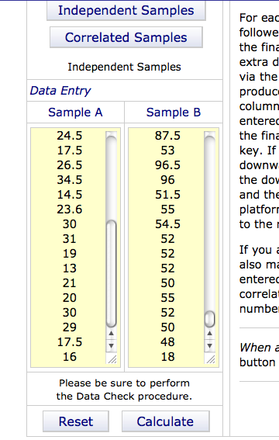

In this case there is a significant difference between metatherian gestation periods and those of eutherians.

**Q: Is there a significant difference between metatherian and eutherian lactation periods?**

1. Click on the **Print This Window** button all the way at the bottom of the page to save a copy of the statistical report..

