**Activity Title: *Body size, geographical distribution, thermal metabolism and how it all relates to the number of offspring.***

**Course: General Zoology**

**Semester planned for implementation: Spring 2012**

**Instructor: Patricia A. Burrowes**

**Brief description of the activity or hypothesis:**

The number of offspring produced by an animal is an important characteristic that defines its fitness, and as such can determine its capacity to survive, colonize a new area, become established and even behave as an invasive species that may bring conservation concerns. The main purpose of this activity is to investigate the relationship between an animal’s body size and the number of offspring it can produce. To understand the complexity of factors that may interact to define a fitness trait, such as the average number of offspring produced by a species, students will also assess the implications of thermal metabolism (endothermyvsectothermy), climatological conditions of their geographic distribution (temperate versus tropical), and evolutionary history (family) of the animals in question. They will work with a family of rodents, the Cricetidae, that includes rats, mice, voles and hamsters in both tropical and temperate regions; and with all theSquamate reptiles for which this type of data is available in the ADW.

**How does this activity facilitate student inquiry?:**

It is generally known that body size is positively related to the number of offsprings an animal can produce (Hendricks and Mulder, 2008; Hill et al., 2010). Through this exercise students are challenged to ask if a theoretical conceptholds from real animal data queried an downloaded from ADW. They get to opportunity to analyze these data graphically and statistically to discover patterns, and then question if the patterns they discover for one group of animals that share similar metabolic characteristics, and evolutionary history hold for an unrelated group that differs in its thermal biology. As a way to expand their knowledge, students are asked to assess if differences in body mass and number of offspring produced are related to the geographical distribution of the species, and thus, have an opportunity to integrate concepts of evolution (fitness), reproductive physiology, biogeography and conservation.

**Terms or concepts important to the activity:**

Body size, Fitness,Endothtermy, Ectothermy, biogeography.

**Instructions for completing the query and report:**

Register into the Quaardvarkwebsit to be able to access their data base: <https://animaldiversity.ummz.umich.edu/quaardvark/>

**QUERY #1:**

1. First, consider the question: What is the relationship between Body mass of a vertebrate animal and the number of offspring it may produce? Since there are too many vertebrate species we will limit our search to a group of mammals in the order Rodentia, the family Cricetidae, which includes many New World (Americas) rats, mice, voles and hamsters.
2. In Quaardvark , go to the “search and report” page, <http://animaldiversity.ummz.umich.edu/quaardvark/search/>.
3. In the Query section:
   1. **Edit** the “Animal Group” section to read “Cricetidae”. Do this by typing “Cric” into the box, wait for a list of possible matches to appear, then select “Cricetidae”
   2. **Save** your changes.

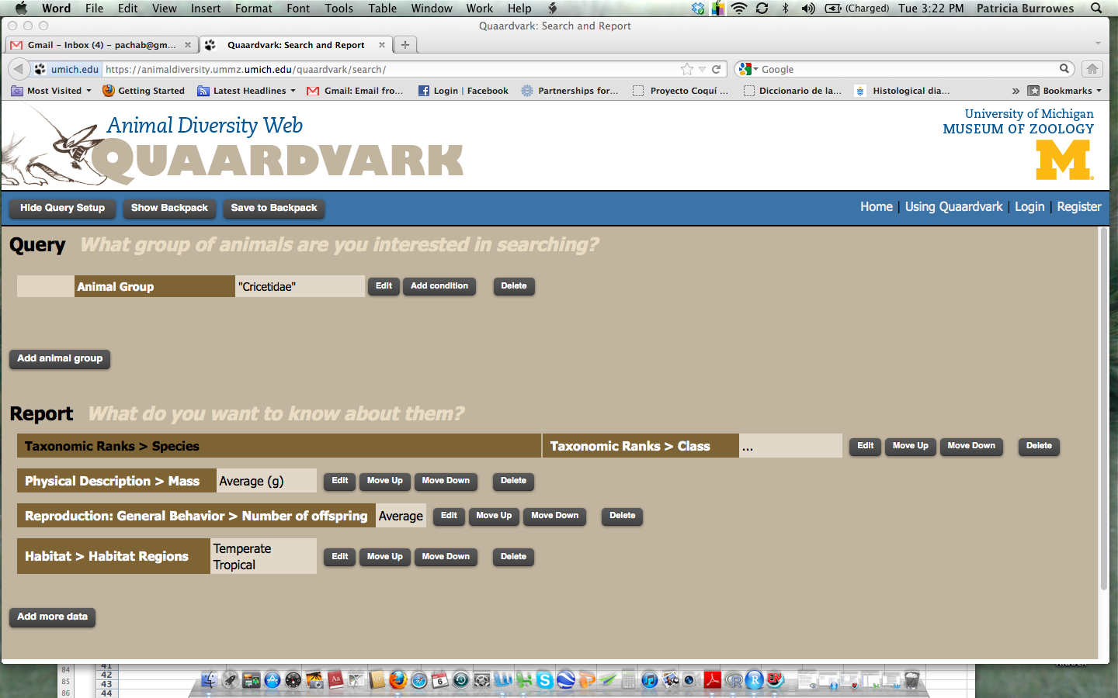

1. In the Report section:
   1. Do not edit the default taxonomic ranks field.
   2. Click on the “add more data” button. Scroll down to Physical description and select it, you’ll then see another list to choose from. Click on “mass.” Select the box for average measurements, and select grams (g) for the units of mass. Then **select the lower box to only include taxa for which this information is available**. Press OK.
   3. Again, “add more data” and scroll down to “Reproduction: General Behavior”, and select “Number of offspring”. Check the box for average number, and the lower box to **only include taxa for which this information is available**. Press OK.
   4. Again, “add more data” and scroll down to “Habitat”, choose“Habitat Regions from the drop-down menu, and select the boxes for “Temperate” and “Tropical” to be included in separate columns. Press OK.
   5. Make sure all windows are closed by clicking “cancel”or “OK”. Click “Submit” and wait for the report to be generated. It will appear on the browser page. You can then download it as an Excel spreadsheet. Open the spreadsheet in Excel, and start organizing your data for the appropriate analyses in order to answer the questions outlined below.
   6. You can also then save this spreadsheet in your “backpack” by uploading it through your course workspace.

**QUERY #2**: For comparative purposes, you will also investigate the relationship between Body mass of another group of vertebrates, a Reptilian order: Squamata, which includes all the amphisbaenas, lizards and snakes.

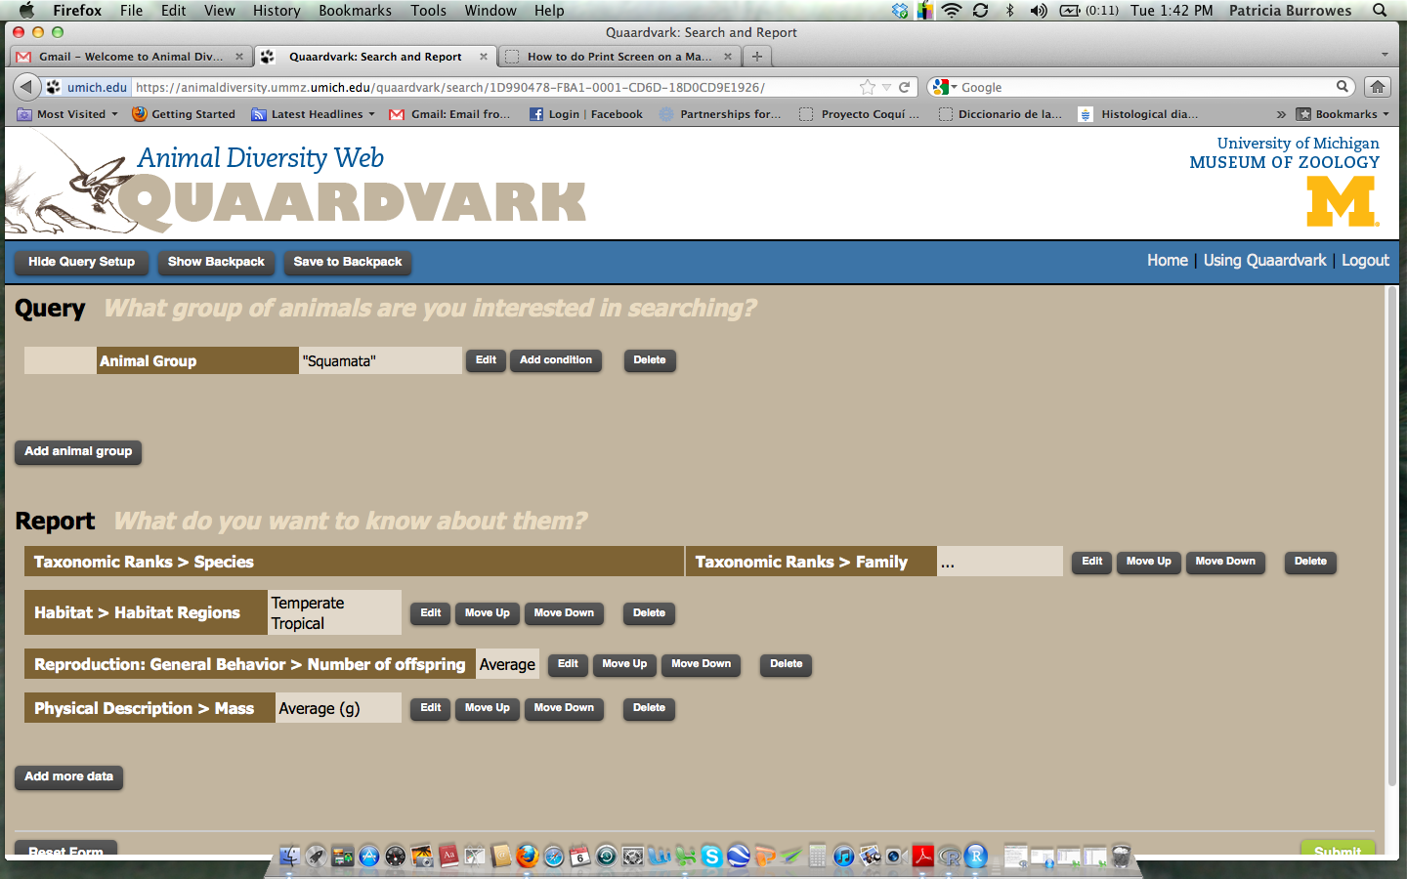

Follow all the steps for Querry #1, with the exception that your animal group will be “Squamata”; and that you will add another field of data:

1. In the Report section:
   1. EDIT the default taxonomic ranks field to include “family” and then **save.**
   2. Proceed querying for the same data you did for the Cricetidae.

**Analyses on downloadable data, if relevant:**

Synthesis, re-organization and transformation of data, scatter plots to observe relationships, linear regressions, analysis of variance. For details see the “Predictions/ Questions/ Analysis Suggestions” section below.

**Graphical analyses of results, if relevant:**

Scatter plots, Linear fit, Boxplots. For details see the “Predictions/ Questions/ Analysis Suggestions” section below.

**Assignment requirements:**

Students will be asked to download “R” and “R-studio” for analysis of their data,alternatively they may use any other statistical packages of their choice.

***Initial data manipulation in Excel:***

When you download your report from Quaarvark on to an Excel worksheet, you will find that the Regions (tropical and temperate) are in different columns. For ease of your data analysis fuse this information into a single column and name it “Region” .

* If a a specie occurs in both the temperate and tropical regions, meaning it has a broad distribution, write “Both”.
* If a species does not have information on region, click the species name; this will take you to the species account in the Animal Diversity Website (you must have Internet access), where you can find the missing data and fill it inn.

**Predictions/ Questions/ Analysis Suggestions:**

1. From what you have learned in the Zoology course would you predict that body mass is a good predictor of the number of offspring an animal can produce? Explain.

* Visualize your data by plotting the two variables to make a scatter plot; but first, determine which is the dependent variable? Make sure this variable is chosen for the Y axis.
* Look at your plot and decide if your data would benefit from some type of transformation to better fit your scales? For example, try logging your data. Why would this be appropriate? Did it help for the Cricetidae data? Did it help for the Squamate data?
* What did you find? Describe your results.
* Is it obvious from your scatter plot of the Cricetidae that there is a group of outliers that may obscure a potential pattern? Who are they? Explain (by reading about them -see their species accounts in ADW), some ecological and or morphological characteristic of these animals that may produce such results.
* Eliminate these animals from your Cricetidae data for the purpose of your statistical analysis.

1. To determine if mass indeed is a good linear predictor of Number of offspring in these groups of animals, perform a linear regression analysis. Define your Null (Ho) and alternative hypotheses (Ha) for this statistical test:

* Ho: slope of the line = 0 meaning that there is no linear relationship between these two variables; Ha: slope ≠ 0; indicating that there is.
* What is the equation of your line? Remember that a line is given by Y= AX +B, where the A is the slope of the line, and B is the estimate of the Y intercept (when X = 0).
* Was this relationship statistically significant? Can you reject your null hypothesis?
* Make a note of the F-statistic, Degrees of freedom, Regression coefficient (R-square) and P-Value.
* Add a fitted line to your plot to visualize the line fitted by the regression analysis.
* Make sure you checked if your data met all the assumptions of the linear regression analysis.

1. Now, consider the effect of the geographical distribution of these animals on the number of offspring they can produce. Would you predict a difference in the number of offspring in animals that occur in tropical versus temperate region? Explain.
2. To investigate if there are differences in the number of offspring associated to geographical regions e.g. temperate vs tropical vs both, you can perform an analysis of variance (ANOVA).

* For this analysis, remember that Y is going to be a continuous variable (# offspring) and X is your categorical variable (region).
* In this case your null hypothesis is Ho: the mean number of offspring in the tropics (μ1) = mean number of offspring in temperate region (μ2) and the mean number of offspring in both temperate regions (μ3). The alternative hypothesis is Ha: (μ1 ≠μ2 ≠μ3 ).
* Graph the results of your ANOVA by selecting a Boxplot. You will be able to see differences in Number of offspring per region because a boxplot illustrates the mean, and the variance around the mean of your data.
* Is this relationship significant? why? why not?
* See what happens if we exclude species that occur in both regions, and re-do the ANOVA.
* Make a note of the F value, Degrees of freedom, and P-Value in every case. Is the number of offspring associated with the geographical region in the Cricetidae? In the Squamates? Was this relationship expected for each of these groups of animals? why? Why not?
* Can you explain the results obtained by considering some particular characteristic of these geographical regions? Which ones? How?
* Are there outliers in your data? Explain.

1. Now you can also assess if the Number of offspring is related to the evolutionary history of Squamates, for which you have information on Families.

* You can do this by graphing box plots by family as we did above for the regions.
* Which family has the highest variation in the number of offsprings? Why?

1. Finally, look at the regression, fitted line plots that you generated for Cricetidae and Squamates, and analyze the slope of those lines.

* If you logged your data, compare the slopes of the equations of the fitted lines for the logged data.
* Try to graph both these regression lines in the same graph so that you can see the patterns better.
* Compare the slopes of these two lines? Do they differ much? What about the y-intercept? What does this tell us biologically—As the mass of a Squamate changes the average reproductive output is (greater, lower, equal ) than for a small mammal?
* What can you say about the number of offspring produced by a Cricetidae (mammal) or a squamate (reptile) of about the same mass?
* What metabolic attribute that characterizes these animals may be responsible for the observed differences? Explain.

**Theoretical Background to be discussed in class:**

In class we will discuss concepts of scaling and metabolism, animal development, reproduction, mating systems, and thermal metabolism: ectothermy and endothermy.

**How is student work assessed?**

Written reports graded with a rubric (see end of document) to assess the level to which students have achieved the following goals:

* ADW query – appropriate according to instructions provided.
* Graphical representation of data: scatter plot, fitted line plot, boxplots.
* Statistical analysis.
* Data interpretation from a statistic and biological perspective.
* Correctness of answers to all questions asked in the assignment.
* Clarity of scientific writing.

The assignment is worth 15 points which is equivalent to ~12 % of the grade attained in the course.

**Additional readings and materials available to supplement this activity:**

**Books:**

Hill, R.W. , G.A. Wyse, and M. Anderson. 2010. Animal Physiology. Sinauer Associates Inc. USA.

Moyes, C. D.and P. M. Shulte 2008. Principles of Animal Physiology 2nd Ed. Benjamin Cummings. USA.

**Websites:**

<http://www.vias.org/physics/bk1_03_03.html> Benjamin Crowel lectures: Scaling applied to Biology.

<http://graphpad.com/curvefit/linear_regression.htm> Graphpad help with Statistics

<http://www.r-project.org/> Home page for R –Statistical computing and graphics freeware.

**Journal Articles:**

Hendricks, A. J. , and C. Mulder. 2008. Scaling of offspring number and mass to plant and animal size: model and meta-analysis. Oecologia. 155(4): 705–716.

|  |  |  |
| --- | --- | --- |
| **Rubric For Quaardvark Activity II - Bodysize/Offspring/Metabolism: Cicetidae vs Squamates** | | |
| ***Concept or Skill Assessed*** | ***Level*** | ***Score*** |
| **Writing:** |  | **3** |
| Paragraphs are vague, wordy, disorganized and/or unclear and do not address main issues. Sentence structure poor. Several errors in spelling and grammar. | Poor | *1* |
| Paragraphs cover the main ideas asked, but could be done in a more detailed manner. Some redundancy in expression of ideas. A few errors of spelling and grammar. | Could improve | *2* |
| Paragraphs introduce reader to the purpose of each question answered. Ideas well organized and presented clearly and concisely- summarize all important biological information. | Good | *3* |
| **Biological Content:** |  | **4** |
| Answers are incomplete and reflect lack of knowledge and understanding of the biological concepts addressed. Biological terms are not properly used. NO link between quantitative results and biological conclusions. | Poor | *1* |
| Only minor errors or minor omissions in biological content are apparent in the answers. A few minor mis-conceptions evident. Terminology is generally well used, but could be improved. Interpretation of statistical results to draw biological patterns deficient. | Could improve | *2 or 3* |
| Answers are biologically founded and show evidence of understanding the underlying concepts; Predictions and/or hypotheses are clearly formulated and represent educated thoughts. Biological terms are used in proper context. Appropriate use of statistical results to draw biological patterns. | Good | *4* |
| **Quaardvark Query results** |  | **2** |
| Data downloaded from ADW incomplete and poorly organized. | Poor | *0* |
| Data downloaded from ADW complete but not organized well for the analyses requested. Transformations well done. | Could improve | *1* |
| Correct and complete ADW data outcome according to instructions. Data properly organized for further analysis. | Good | *2* |
| **Data Analysis** |  | **4** |
| Statistical analysis lacking or incomplete; statistical hypotheses absent or incorrectly formulated, outcome of the tests not interpreted correctly, and/or not related to the biological aspects in question. Corresponding graphs lacking, incomplete or mislabeled. | Poor | *1* |
| Some statistical analysis lacking or incomplete; test-statistics reported, but mis-interpreted. Some of the corresponding graphs lacking or incomplete. | Could improve | *2* |
| All statistical tests performed correctly, statistical parameters reported and statistical significance interpreted correctly; data transformations appropriate and well justified in the text. | Good | *4* |
| **Graphical Analysis and Presentation** |  | **2** |
| Many relevant graphs are missing. Graphs are poorly designed and not related to the statistical analysis expected. Presentation inappropriate, lacking title, labels and/or units. | Poor | *0* |
| Some relevant graphs are missing. Graphs correspond to the required statistics, but some important parameters, labels or transformations missing. Presentation could be improved by including some missing information: title, labels and/or units. | Could improve | *1* |
| All relevant graphs are presented. Graphs design is correct and in agreement with corresponding statistical test. Presentation is accurate and include: title, correctly labeled axis, and units. Biological interpretation of results is appropriate. | Good | *2* |