**BIOL 232: Dr. Francl**

**Relating natural history traits to Basal Metabolic Rate (BMR)**

In class this week, we defined the basal metabolic rate as the amount of energy sufficient for all vital body functions (heart, lungs, nervous system, kidneys, liver, intestines, reproductive organs, muscles, skin). We discussed the relationship between basal metabolic rate and body mass in lecture, and reviewed this slide:

**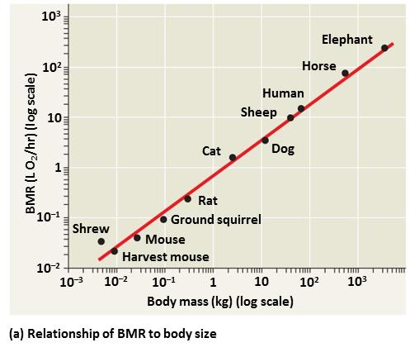**

So BMR is affected by an animal’s daily behavioral patterns, reproductive functions, and more. Let’s use Quaardvark to look at natural history traits that could be driven by or related to BMR.

Unfortunately at this time, ADW lacks sufficient information for BMR in its species accounts (but the data are coming soon!). So let’s use body mass as a stand-in for BMR.

What life habits might be affected by BMR?

* Aspects of reproduction?
* Endothermy vs. ectothermy?
* Aspects of behavior (e.g., nocturnal vs. diurnal)?
* Food preferences (carnivores vs. herbivores)?

You choose! NOTE: choose two groups of animals with a manageable number of species (TRY to limit your total number of species examined to 300).

**Dr. Francl’s example search:**

I wanted to compare BMR trends in endotherms vs. ectotherms. To trim this down to a manageable number of specimens, I selected to compare two relatively similar groups (from a phylogenetic perspective): birds (endotherms) vs. reptiles (ectotherms).

My questions:

1. is there a relationship between BMR (mass) and the number of offspring an individual produces?
2. Is there a difference in this trend between endotherms (birds) and ectotherms (reptiles?)

So, I set up the following query in Quaardvark:

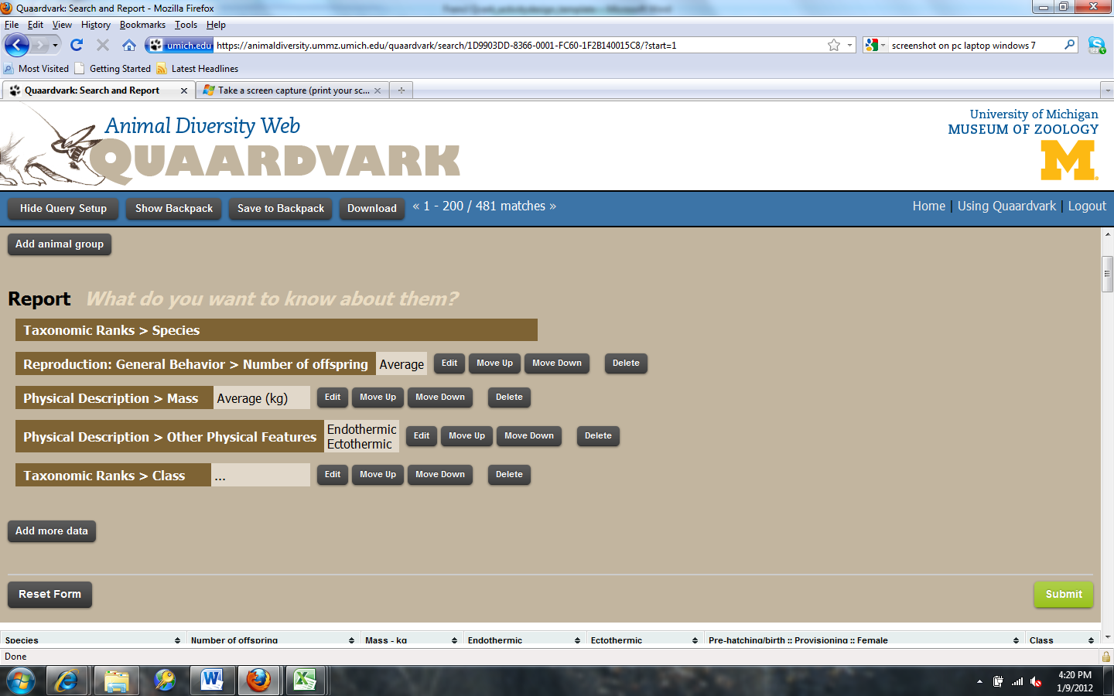

I then exported the spreadsheet to Excel and graphed a comparison between the two groups, and here is a portion of what I exported:

|  |  |  |  |  |
| --- | --- | --- | --- | --- |
| Species | Number of offspring | Mass - kg | Endothermic | Class |
| [Acanthorhynchus tenuirostris](http://animaldiversity.ummz.umich.edu/site/accounts/information/Acanthorhynchus_tenuirostris.html" \t "_parent) | 2 | 0.011 | YES | Aves |
| [Accipiter cooperii](http://animaldiversity.ummz.umich.edu/site/accounts/information/Accipiter_cooperii.html" \t "_parent) | 4.5 | 0.5266 | YES | Aves |
| [Accipiter gentilis](http://animaldiversity.ummz.umich.edu/site/accounts/information/Accipiter_gentilis.html" \t "_parent) | 3 | 0.9975 | YES | Aves |
| [Acridotheres tristis](http://animaldiversity.ummz.umich.edu/site/accounts/information/Acridotheres_tristis.html" \t "_parent) | 4.5 | 0.1125 | YES | Aves |
| [Acrocephalus arundinaceus](http://animaldiversity.ummz.umich.edu/site/accounts/information/Acrocephalus_arundinaceus.html" \t "_parent) | 4.5 | 0.036 | YES | Aves |
| [Acrochordus granulatus](http://animaldiversity.ummz.umich.edu/site/accounts/information/Acrochordus_granulatus.html" \t "_parent) | 6 | 0.13 |  | Reptilia |
| [Actitis hypoleucos](http://animaldiversity.ummz.umich.edu/site/accounts/information/Actitis_hypoleucos.html" \t "_parent) | 4 | 0.04 | YES | Aves |
| [Agkistrodon piscivorus](http://animaldiversity.ummz.umich.edu/site/accounts/information/Agkistrodon_piscivorus.html" \t "_parent) | 7 | 1.0675 |  | Reptilia |
| [Alligator mississippiensis](http://animaldiversity.ummz.umich.edu/site/accounts/information/Alligator_mississippiensis.html" \t "_parent) | 61.5 | 150 |  | Reptilia |

Here is a graph of all the data. Because there was a wide range in mass, I transformed it to a Log base-10 scale (Format axis 🡪 check box for Logarithmic scale, base 10). So I could see trends easier, I also showed a trend line (right-click on data points, select “Add trendline”).

How might you interpret this?

1. Mass (as a stand-in for BMR) does NOT affect the number of offspring in endotherms or ectotherms?
2. Mass affects the number of offspring in ectotherms but never endotherms?
3. Mass affects the number of offspring in ectotherms only when you reach a critical mass?

**What do you think? Do we have enough data to answer our question? Do we have too much data to answer our question?** (Answer below)

Next, go back to the Excel spreadsheet.

Sort by number of offspring, from lowest to highest.

* Which of the ectotherms have the highest number of eggs?
* Are they limited to a certain group of reptiles?
* What do you know about these species natural history that makes them different from other reptiles?
* How would your results change if this group were removed?
* Does this change your conclusions above?
* Was it a good idea to compare ALL ectotherms vs. ALL endotherms? Why or why not?

**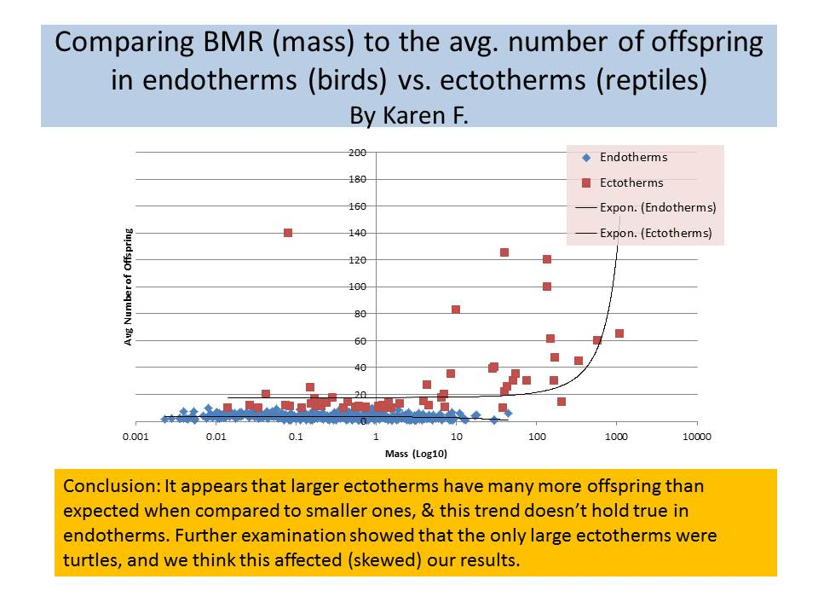**

**Your project:**

1. Compare BMR (or mass) to a particular natural history characteristic - one that you expect to be related to BMR.
   1. why might this natural history metric be related to BMR?
   2. Set up your query, and include 2 major groups to compare (ectothermic reptiles vs. endothermic birds, bony fish vs. cartilaginous fish, herbivore mammals vs. carnivore mammals, etc.). You can even do a subset of the critters graphed above!
   3. Note: You may want to play around with a few traits or a few animal groups until you feel you have large enough sample sizes to tell a story.
2. Graph the relationship in Excel as a scatterplot. Explain the trends you see. Can you use BMR to explain these trends?
3. Using the powerpoint slide above as a template, create a single powerpoint slide, giving it a title (what are you comparing), add the Excel graph, and a sentence or 2 explaining your conclusions. You’ll present this in class on Wednesday ☺

**How to create a scatterplot in Excel, using 2 groups**

1. Sort your data by your 2 groups (Endotherms vs. Ectotherms, 1 family vs. another, 1 feeding type vs. another, etc. Just Sort by that Column that differentiates the 2 groups.
2. Insert 🡪 Scatterplot 🡪 Scatter with only markers
3. In Chart Tools 🡪 Design 🡪 Select Data
4. Add your 2 sets of data, one at a time
   1. In Legend Entries (Series) 🡪 Add 🡪
      1. Series name – your first group name (Endotherms, Ectotherms, etc.)
      2. Series X Values – highlight all the cells in the Mass column for all your species in that category
      3. Series Y Values – highlight the cells in the column for the metric you have chosen that fall into that same category
   2. Add a Legend Entry for your 2nd group, using the same steps
5. Add a Trendline for each of the two datasets on your graph – right-click on any datapoint and select “Add Trendline.” What type of line fits best? Linear? Exponential? You decide.
6. Label your x- and y-axis with appropriate titles (Mass in grams, Number of offspring, etc.) Chart Tools🡪 Layout🡪 Axis Titles