MATH in SCIENCE: Calculating Maximum Estimated Bite Force from Dog & Cat Skulls Accessed on the Quaardvark Database

Purpose:

The purpose of this lab activity is to learn more about different species of dogs and cats by looking at their skull morphology and using images of their skulls to calculate their maximum estimated bite force. The activity uses the Quaardvark query and search tool from the University of Michigan and Image J, a free online photo tool.

Materials:
- Computer with Internet Access and ability to download programs (These instructions were created using a PC with Windows Vista).

- Calculator

Procedure/Instructions:

Introduction:
- Begin by downloading Image J from the internet (Image J is a free program in the public domain)
  - Go the following link: http://rsbweb.nih.gov/ij/download.html
  - Download the version of Image J appropriate for your computer/operating system.

- Create a Quaardvark account or login to your existing account by clicking Login or Register at the left side of the page at the following link: https://animaldiversity.ummz.umich.edu/quaardvark/

- Instructions on how to use Quaardvark can be found on the site by clicking on How to Use Quaardvark on the left side of the page.

- For this activity, you will be using Quaardvark to search for images of both dog and cat skulls.

- Image J will then be used to measure the skulls for calculating the Maximum Estimated Bite Force (MEBF).

Attaining Images via Quaardvark:
- Click on Query & Report.

- You will first find skull and jaw images of species in the Canidae family.
  - Edit the Animal Group to “Canidae” and click Save.
  - Click Edit at the first box under Report.
  - Click Media Assets: Specimens.
  - Click Skull.
  - Either check the “Skull” box at the top of the list OR check the following boxes: “Dorsal View”, “Lateral View”, and “Ventral View”. These three pictures are what you will need to proceed with the calculations.
  - Click Save Changes.
  - Click Add more data.
  - Click Media Assets: Specimens.
  - Click Lower Jaw.
  - Check the “Lateral View” box.
  - Click Save Changes.
  - To finalize you Query & Report, click Submit in the bottom right corner.

- You should now have a table with both skull and lower jaw images compiled from Animal Diversity Web.

- To save your Query & Report, click Save to Backpack at the top of the page. To access this query again later, click Show Backpack.

- Repeat steps 1 & 2 to attain images for cats. In “a” under step 2, Edit the Animal Group to “Felidae” instead of “Canidae”.

Using Image J to Gather Data:
- Create folder on your computer to place all of the pictures that you will be using for calculations.

- In these instructions, the Coyote (Canis latrans) is used as an example.

- In order to make the images from Quaardvark available in Image J, click on the Dorsal View image in the first column under the Canis latrans.

- Right click on the expanded image and click Save Image As.

- Locate your folder for you images, rename the picture to “coyote dorsal view” or something similar, and then click Save.

- Repeat steps 3-5 for the Lateral View, Ventral View, and Lower Jaw Lateral View images of Canis latrans.

- Once you have saved all of the pictures in your folder, open Image J.

- Click File then Open and locate the Ventral View image of the coyote skull in your folder.

- In order to gather numbers that can be used in you calculations, you must first determine the scale of the picture (number of pixels in 1 cm).
  - Click the Straight Segment Tool
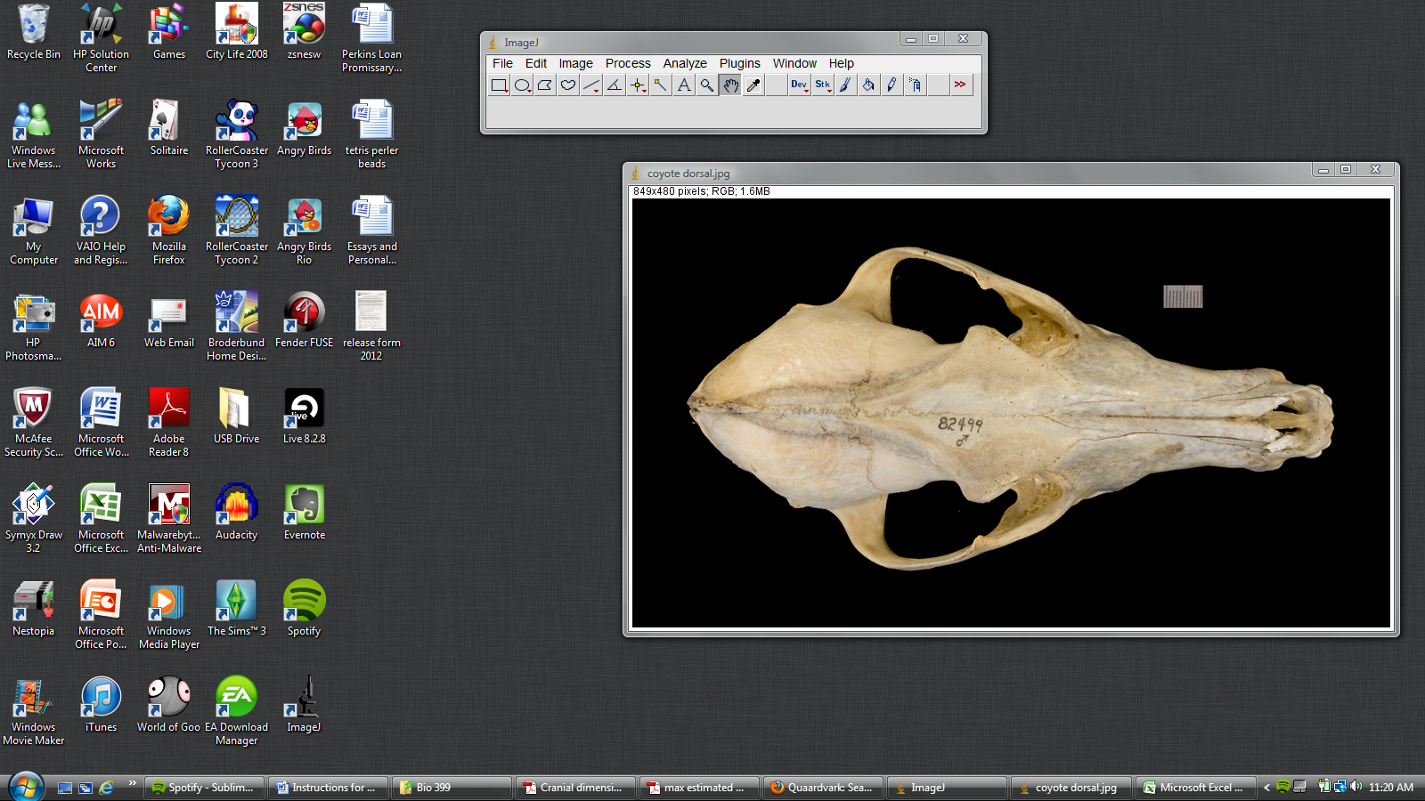

  - Use the tool to measure the length of the scale in the image by right clicking, holding it down, and dragging the cursor across the scale from the mark on one end to the other mark on the other end.

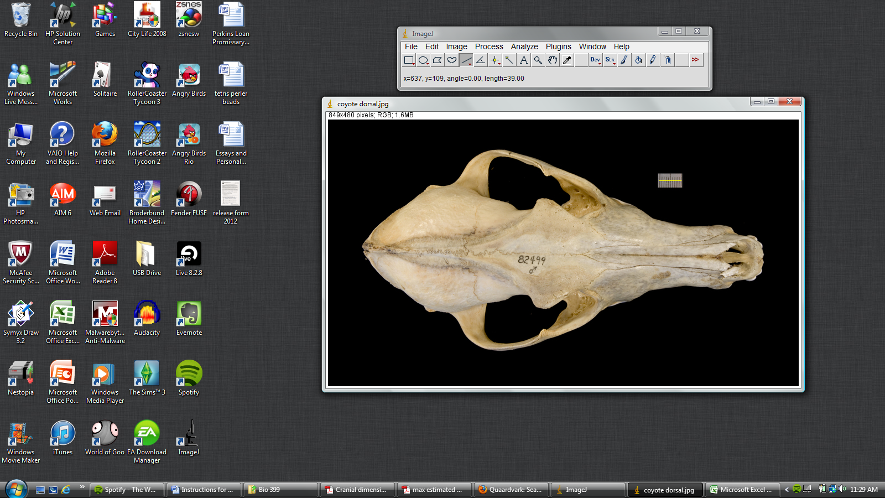

As you measure, the length of your line in pixels will show under the tool bar. Record this number in Table C under Ventral (your number may be different from the example shown).

IMPORTANT: At this point, you may NOT adjust the size of the image because it will cause the scaling to be inaccurate. You must measure the scale and the skull in the image WITHOUT changing the size in between measurements to be accurate.

- Next, you will measure the skull to attain the area of the cross section of the masseter/pterygodial muscle.
  - Click either the Rectangular or Oval tool. Depending on which tool you use, you will calculate the area differently.

  - Right click and hold to drag your figure over the area occupied by the masseter and pterygodial muscles.

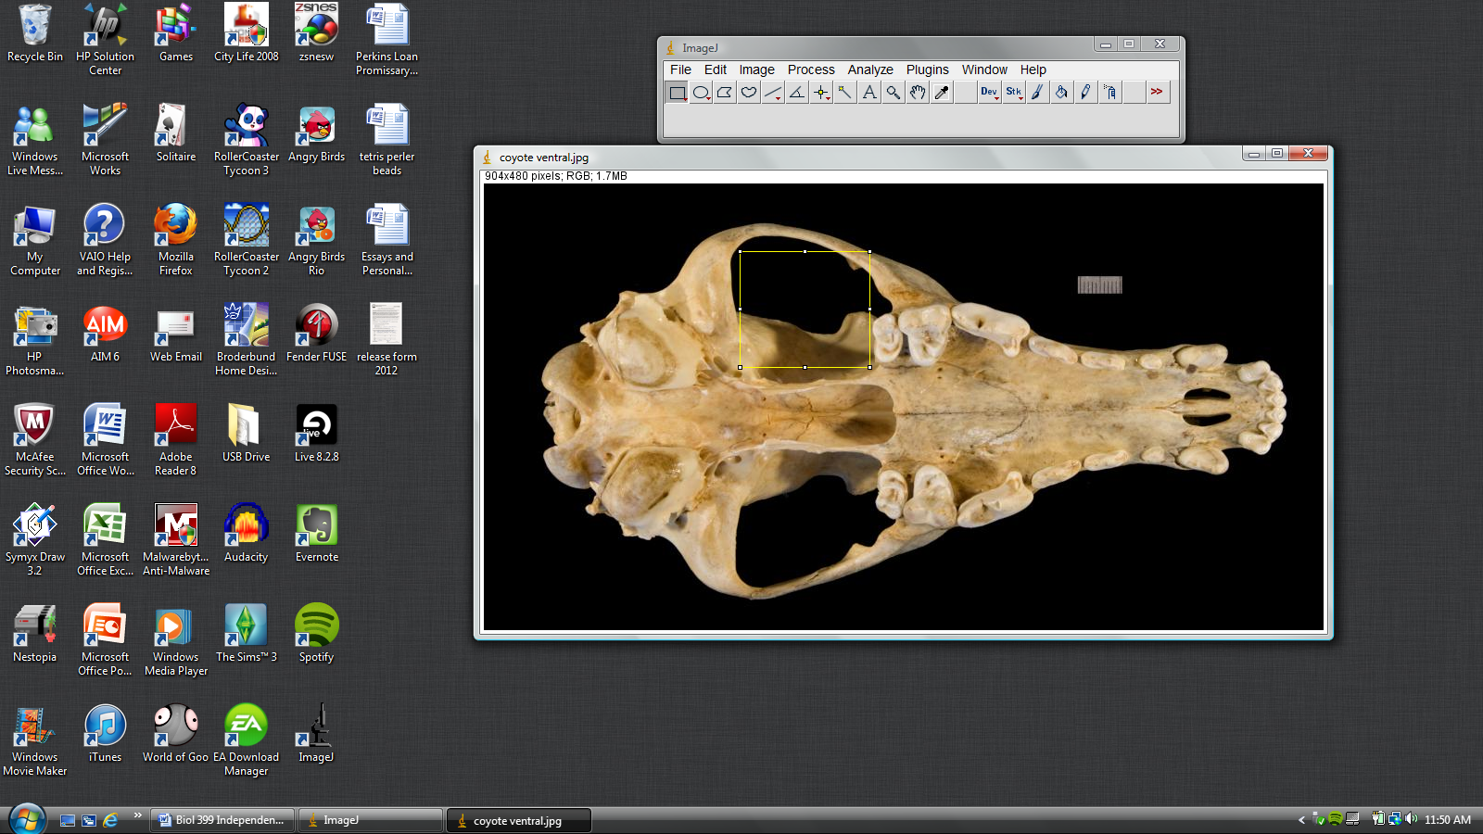

OR

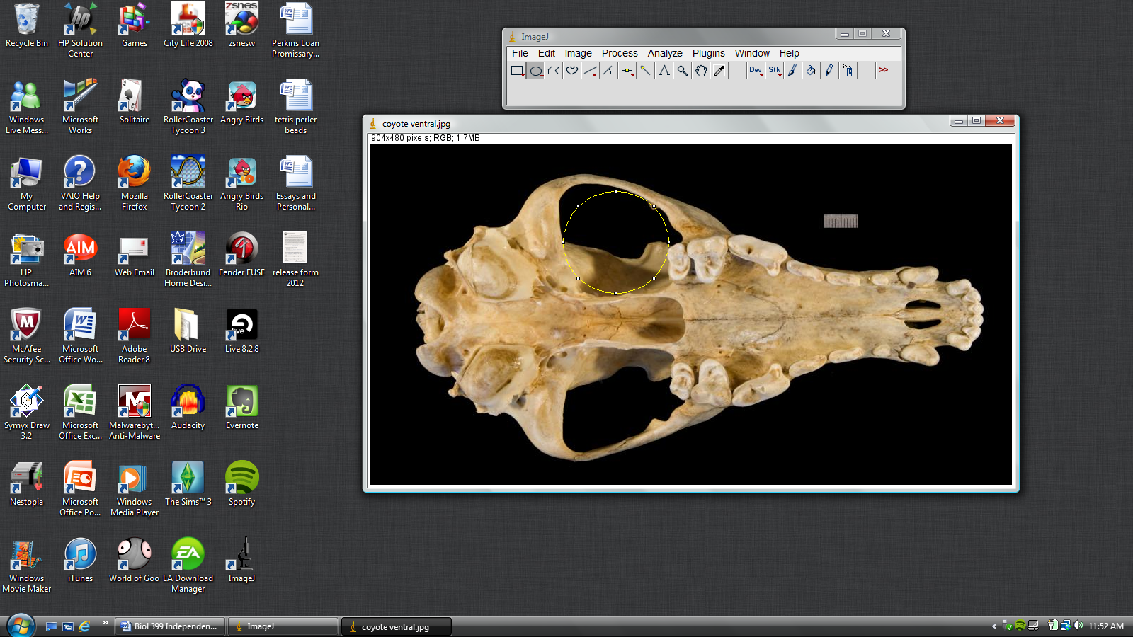

As you measure the opening, the dimensions of the figure will show under the tool bar. Record these measurements in Table A under Masseter/Pterygodial Width and Height in pixels.

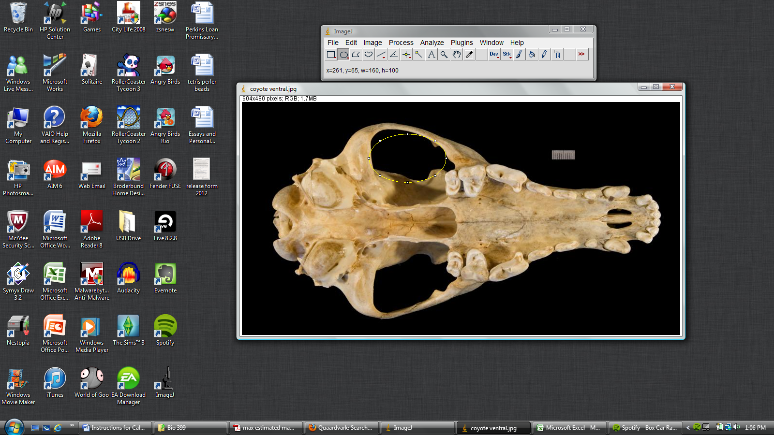

- The next measurement is to attain the area of the cross section of the temporalis muscle. You will need to do two separate measurements for this area, one on the Dorsal View and one on the Lateral View.
  - Click File then Open and locate the Dorsal View image of the coyote skull in your folder.
  - Repeat step 9 to scale the image and record the number of pixels in 1 cm in Table C under Ventral.
  - Use the Straight Segment Tool to measure the width of the opening for the temporalis muscle.

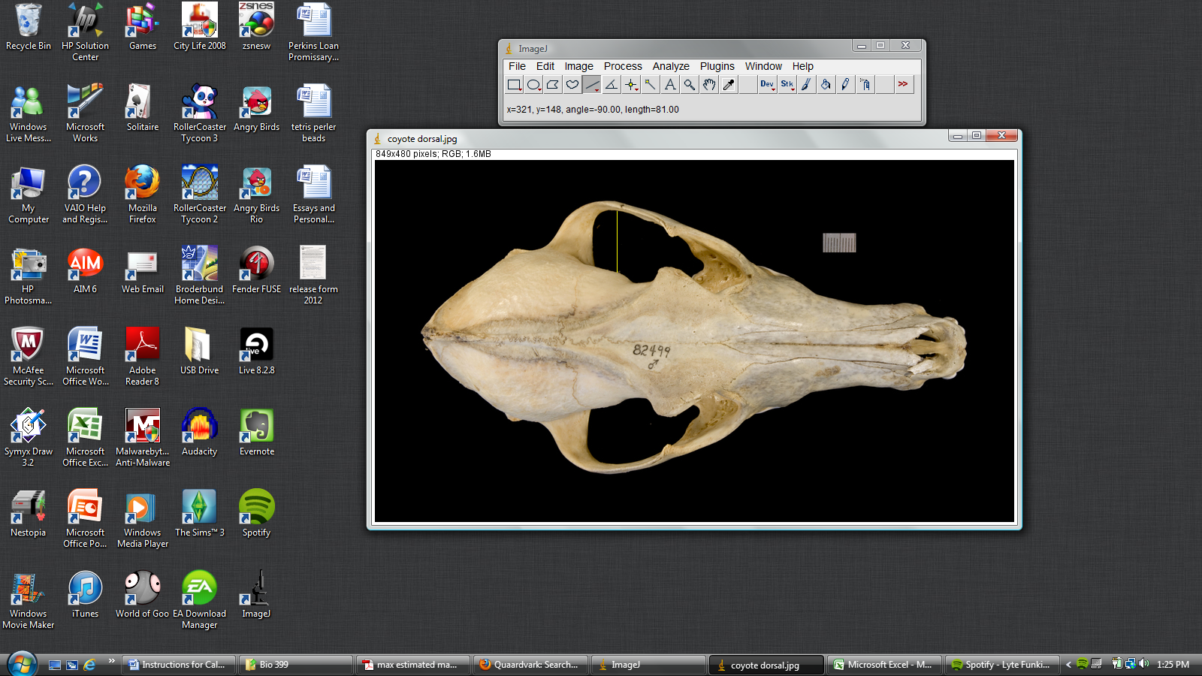

Record the length measurement in Table A under Temporalis Width in pixels.

  - Next, click File then Open and locate the Lateral View image of the coyote skull.
  - Repeat step 9 to scale the image and record the number of pixels in 1 cm in Table C under Lateral.
  - Use the Straight Segment Tool to measure the length of the opening for the temporalis muscle to achieve the other dimension. Record the measurement as the other dimension in Table A under Temporalis Height in pixels.

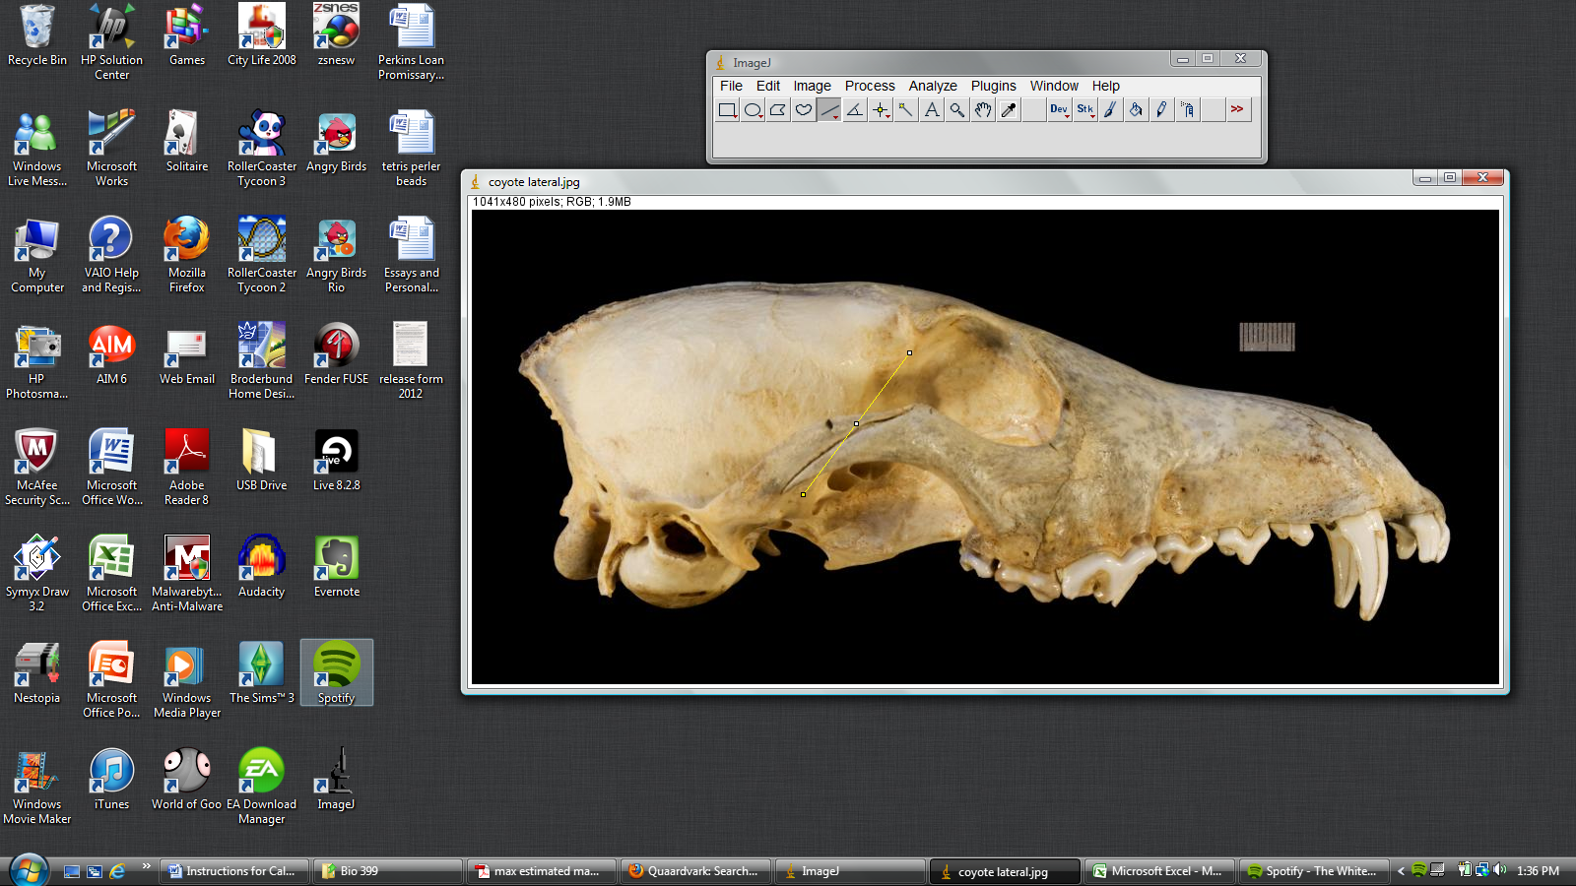

- The final three measurements for the calculations use the Straight Segment Tool on the Ventral, Lateral, and Lower Jaw Lateral views.
  - Measure the Masseter Moment Arm in the Ventral View and record the value in Table B under Masseter Moment Arm Length in pixels (A moment arm is measured as the distance from the center of the maximum cross section area of the muscle to the joint where the muscle translates the force).

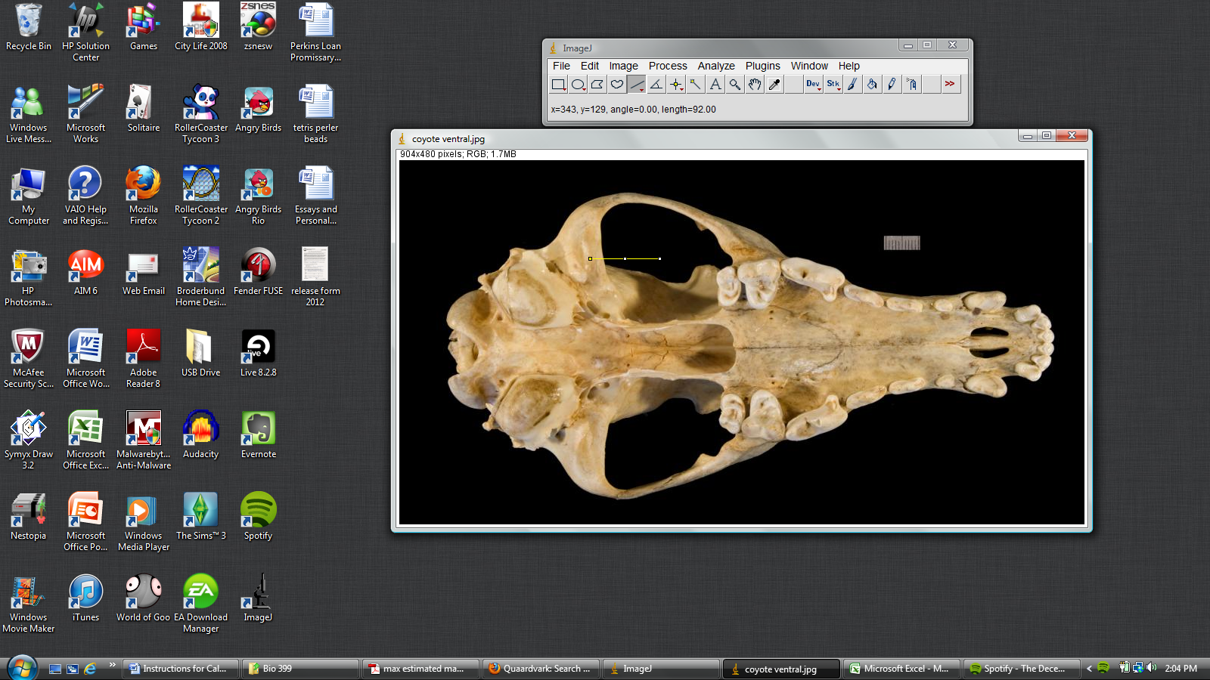

  - Measure the Temporalis Moment Arm in the Lateral View and record the value in Table B under Temporalis Moment Arm Length in pixels.

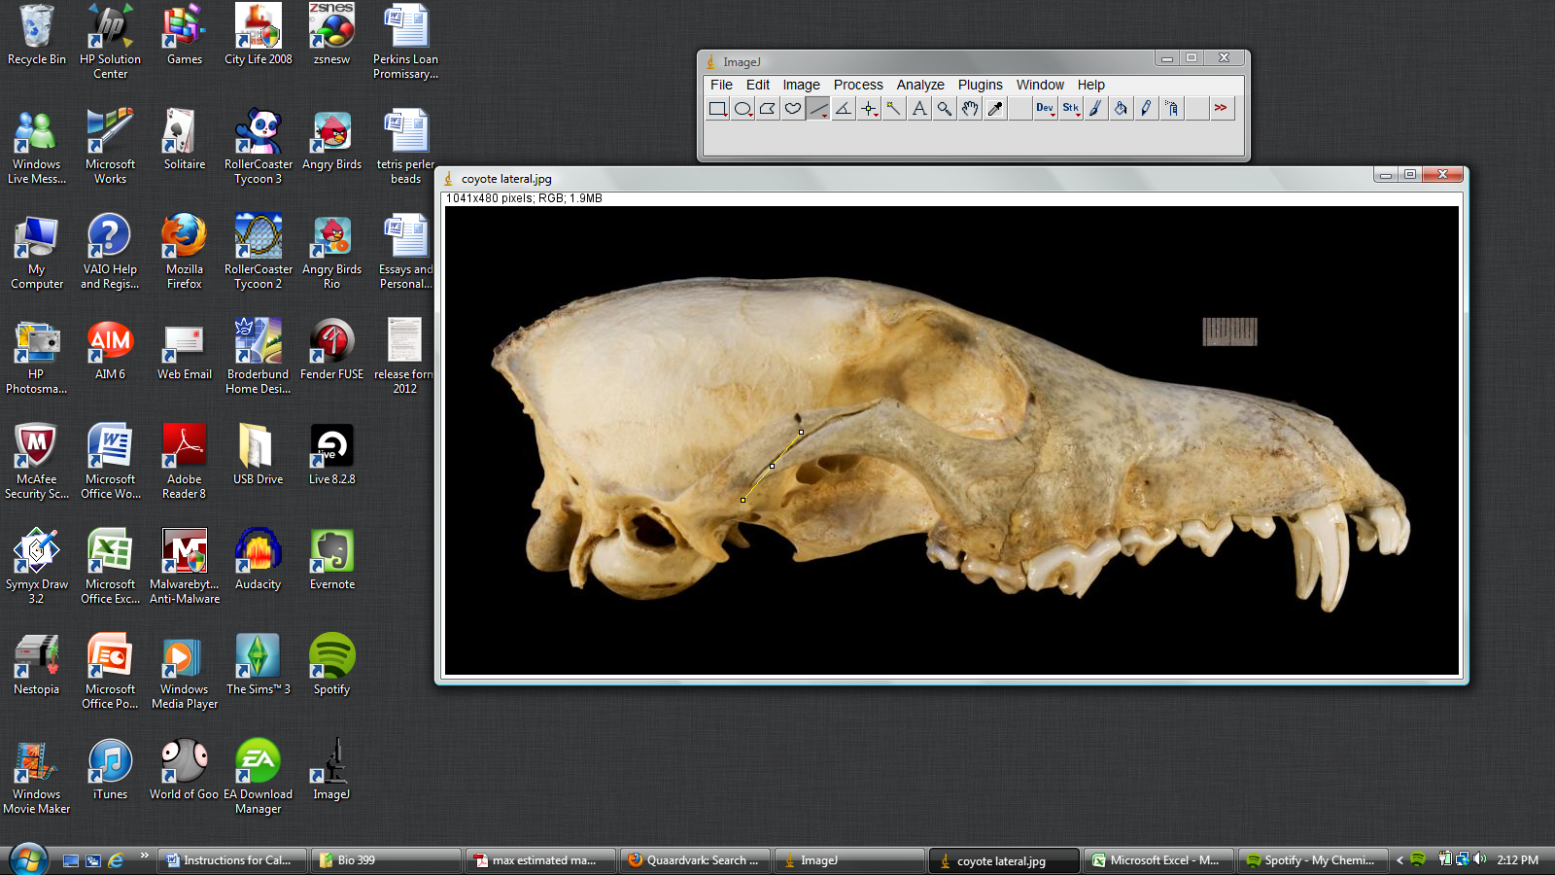

  - Repeat step 9 to scale the Lower Jaw Lateral View image and record the number of pixels in 1 cm in Table C under Lower Jaw. Measure the length of the lower jaw in the Lower Jaw Lateral View and record the value in Table B under Lower Jaw Length in pixels (Lower Jaw Length is measured from temporal mandibular joint to the point of the highest force applied to the jaw).

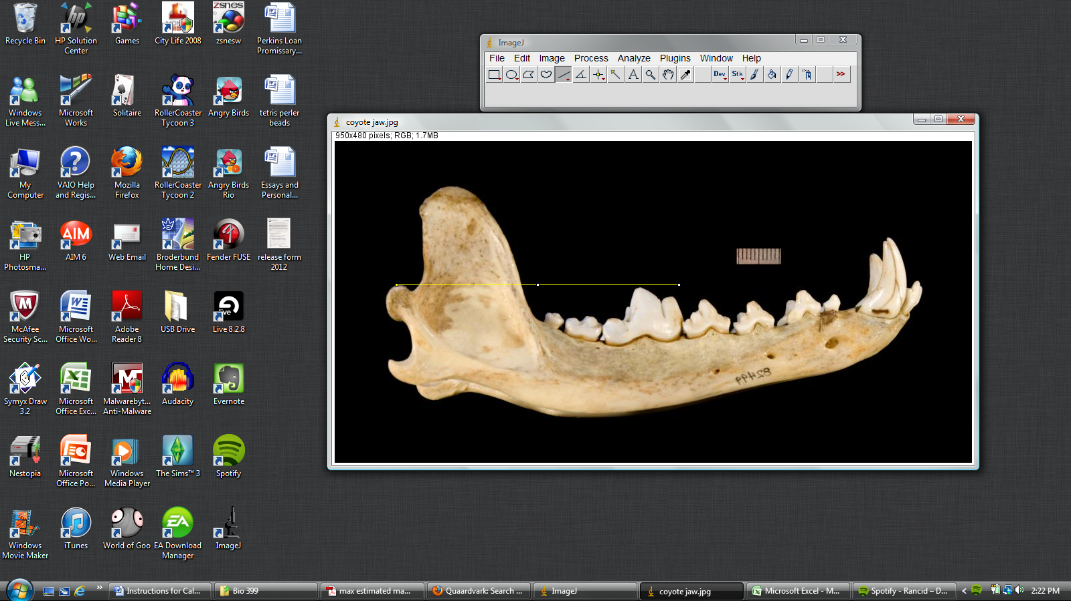

- This concludes all of the measurements you attain from the Quaardvark images.

Calculating Maximum Estimated Bite Force (MEBF)

The following formula is derived from a version of Thomason’s (1991) to estimate the maximum bite force. This formula estimates the maximum bite force by using the cross-sectional area of the muscles and multiplying them by 300 Mpa, the average force per area of a muscle. You will use your data achieved from measuring the images in order to calculate the MEBF for the species of interest. The formula gives MEBF in Newtons (N).

$$MEBF=\frac{\left[\left(M*m\right)+ \left(T*t\right)\right]}{Lj}$$

M = area of the masseter/pterygodial muscles in cm² multiplied by 300 Mpa
m = length of masseter moment arm in cm
T = area of the temporalis muscle in cm² multiplied by 300 Mpa
t = length of temporalis moment arm in cm
Lj = length of the lower jaw in cm

In order to convert you data into values that you can use in the equation, you must divide each measurement by the corresponding number of pixels in one cm (Table C) from the image it was taken from. For example, in the instructions the scale of the Ventral View picture of the coyote skull was 39 pixels in 1 cm. Therefore, the measurements of the Width and Height of the masseter/pterygodial muscle opening in pixels that were taken from the Ventral View are divided by 39. This would give the measurements in cm, which would then be recorded in Table A under W and H in cm. In order to complete the calculation, you must first convert your data into cm (Tables A and B). Be careful when converting the measurements for the cross-sectional area of the temporalis muscle since the two measurements came from different images.

After converting all of your data, calculate the area in cm² of the two muscles. Depending on which tool you used for the masseter/pterygodial muscle measurement, calculate the area of the rectangle or oval. You may do the calculation for the area of the Temporalis muscle using the same method.
$$Area of a Rectangle=W*H$$

$$Area of an Oval=\frac{W}{2}*\frac{H}{2}*π$$

Once you have calculated the cross sectional areas for each muscle, you should now have all of the data necessary to calculate the MEBF. Use the data gathered from following the instructions on measuring the coyote skull to calculate its MEBF and fill it in Table D.

Following the same the instructions for calculating the MEBF for the coyote, calculate the MEBF of the dog and cat species in Tables D and E. Use this data to help answer the discussion questions (you may also use the Microsoft Excel MEBF Calculator for Image J).

Data Tables:

Table A
Muscle | Width in pixels | Height in pixels | W in cm | H in cm | Area in cm²
Masseter/Pterygodial
Temporalis

Table B
Location of Measurement | Length in pixels | Length in cm
Masseter Moment Arm
Temporalis Moment Arm
Lower Jaw

Table C
View | Pixels in 1 cm
Ventral
Dorsal
Lateral
Lower Jaw

Table D
Canidae Species | Common Name | MEBF (N)
Ex: Canis latrans | Ex: Coyote
Canis lupus | Gray Wolf (Domestic Dog)
Canius rufus | Red Wolf
Urocyon cinereoargenteus | Gray Fox
Vulpes vulpes | Red Fox

Table E
Felidae Species | Common Name | MEBF (N)
Felis catus | Domestic Cat
Felis silvestris | Wild Cat
Panthera leo | Lion
Panthera tigris | Tiger
Panthera pardus | Leopard

Background on Canidae and Felidae Species:

Size:
- Mass Range: 7-21kg (15.42-46.26 lb)
- Length Range: 75-100cm (29.53-39.37 in)

Food Habits:
- Young coyotes are fed regurgitated food
- Coyotes are carnivorous; 90% of their diet is mammalian.
Animal foods consist of:
  - Birds, Mammals, Reptiles, Carrion, Terrestial Non-Insect Arthropods, Terrestial Worms,
Plant foods consist of:
  - Leaves and Fruits

Known Predators:
- Humans (Homo sapiens)
- Gray Wolves (Canis Lupus)
- Mountain Lions (Puma concolor)

Canis latrans
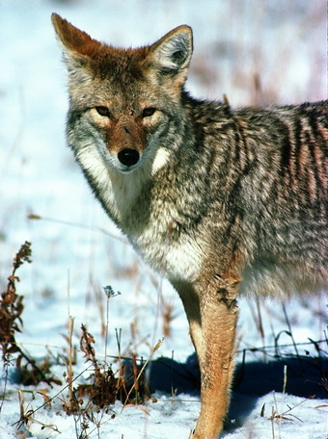
Corel Photograph Collection
(copyright holder), Corel

Canis lupus
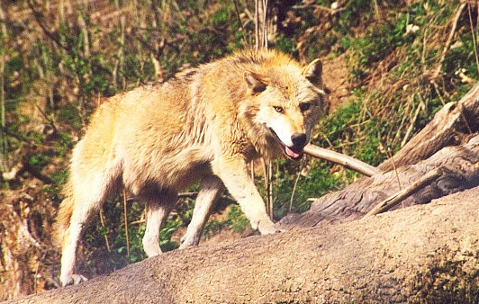
Size:
- Mass Range: 23-80kg (50.66-176.21 lb)
- Length Range: 870-1300mm (34.25-51.18 in)

Food Habits:
- Young gray wolves are fed regurgitated food
- Gray wolves are carnivorous, they hunt large prey. They attack the rump, flank, and shoulder areas.
Animal foods consist of:
  - Mammals, Carrion, Moose, Elk, Bison, Musk Oxen, Reindeer

Known Predators:
- Coyotes (Canis Latrans)
- Gray Wolves (Canis Lupus)

Eva Hejda (photographer; copyright holder; identification)

Canius rufus
Size:
- Mass Range: 20-40kg (44.05-88.11 lb)
- Length Range: Not Noted.

Food Habits:
- Young red wolves are cared for and nursed for first year of life.

Animal foods consist of:
  - Birds, Mammals, Carrion, Raccoons, White-Tailed Deer, Swamp Rabbits, Cottontail Rabbits, Pigs, Rice Rats, Nutria, and Muskrats

Plant foods consist of:
  - Fruits

Known Predators:
- Gray Wolves (Canis Lupus)
- Mountain Lions (Puma concolor)
- Alligators, Large Raptors, and Bobcats (young red wolves predators)

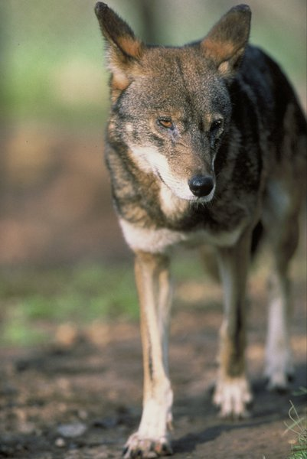
United States Fish and Wildlife
Service (copyright holder)

Urocyon cinereoargenteus
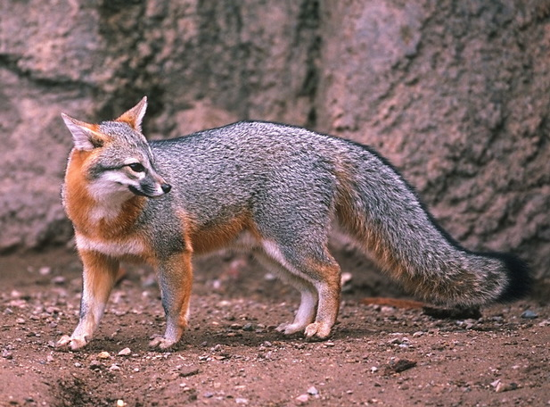
Size:
- Mass Range: 2-9kg (4.41-19.82 lb)
- Length Range: 1000mm (39.37 in)

Food Habits:
- Gray fox pups begin eating solid food around 3 weeks old and start hunting around 4 months old.
- Gray foxes are omnivorous

Animal foods consist of:
- Birds, Mammals, Carrion, Eggs, Insects, Terrestrial Non-Insect Arthropods
Plant foods consist of:
  - Roots and Tubers, Seeds, Grains, and Nuts, Fruit

Known Predators:
- Coyote (Canis latrans)
- Bobcat (Lynx rufus)
- Golden eagle (Aquila chrysaetos)
- Great horned owl (Bubo virginianus)

Corel Photograph Collection (copyright holder), Corel

Vulpes vulpes
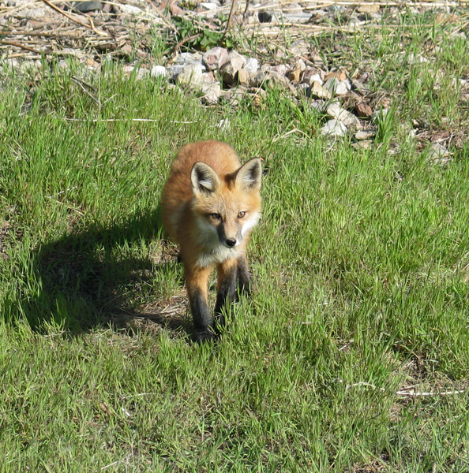
Size:
- Mass Range: 3-14kg (6.61-30.84 lb)
- Length Range: 455-900mm (17.91-35.43 in)

Food Habits:
- Red fox pups are nursed for 56 to 70 days and are fed solid food.
- Red foxes are omnivorous

Animal foods consist of:
- Birds, Mammals, Carrion, Reptiles, Insects, Terrestrial Non-Insect Arthropods
Plant foods consist of:
  - Fruits

Known Predators:
- Eagles (Accipitridae)
- Coyotes (Canis latrans)
- Gray wolves (Canis lupus)
- Bears (Ursidae)
- Mountain lions (Puma concolor)
- Humans (Homo sapiens)

Philip Myers (photographer; copyright holder)

Felis catus
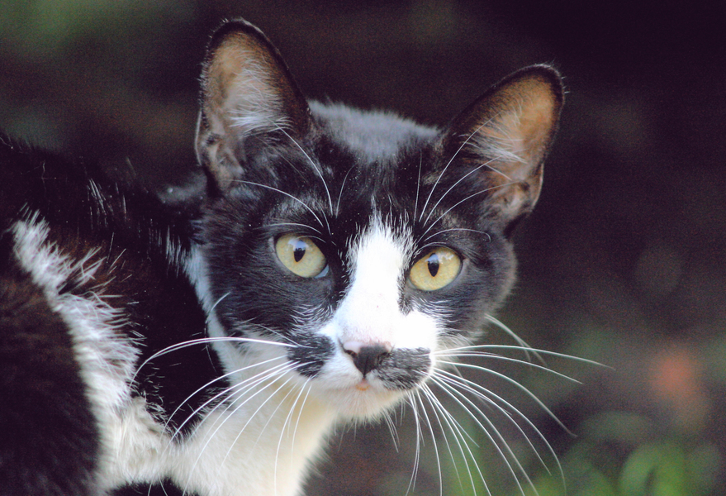
Size:
- Mass Range: 4.1-5.4 kg (9.03-11.89 lb)
- Length Range: 76.2cm (30.00 in)

Food Habits:
- Domestic cats are carnivorous
- Healthy diet consists of about 30 to 35% muscle meat, 30% carbohydrates, and 8 to 10% fats

Animal foods consist of:
- Birds, Mammals, Fish, Insects,
Plant foods consist of:
  - Leaves

Known Predators:
- None Listed

Luis Cesar Tejo (photographer; copyright holder; identification)

Felis silvestris
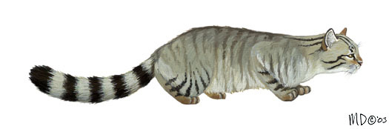
Size:
- Mass Range: 3.5-5 kg (7.71-11.01 lb)
- Length Range: None Listed

Food Habits:
- Wild cats are carnivorous
- Diet is mainly made up of small rodents

Animal foods consist of:
- Birds, Mammals, Reptiles, Carrion, Insects, Terrestial Non-Insect Arthropods

Known Predators:
- Red foxes (Vulpes vulpes)
- Gray wolves (Canis lupus)
- Domestic cats (Felis silvestris)
- Owls (Strigiformes)
- Hawks (Accipitridae)

Michigan Science Art (copyright holder)

Panthera Leo
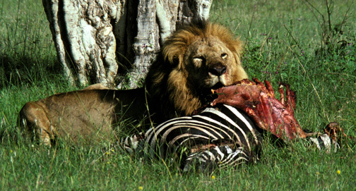
Size:
- Mass Range: 126-272 kg (277.53-599.12 lb)
- Length Range: 2.4-3.3m (7.87-10.83 ft)

Food Habits:
- Young lions are nursed
- Lions are predatory carnivores

Animal foods consist of:
- Birds, Mammals, Reptiles, Carrion, Amphibians, Eggs, Fish, Zebras

Known Predators:
- Spotted hyenas (Crocuta crocuta)
- Humans (Homo sapiens)
Kay Holekamp (photographer; copyright holder; identification), Michigan State University

Panthera tigris
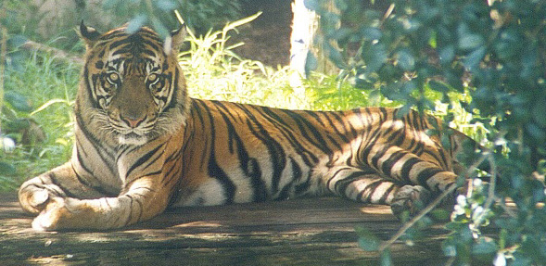
Size:
- Mass Range: 91-423 kg (200.44-931.72 lb)
- Length Range: 1.98-3.7 m (6.50-12.14 ft)

Food Habits:
- Tiger cubs are dependent on mothers. Between 18mos-3yr old they become proficient hunters.
- Tigers are predatory carnivores

Animal foods consist of:
- Birds, Mammals, Reptiles, Carrion, Large Ungulate Species

Known Predators:
- Tigers have no natural predators, except for humans.
- Adult tigers are potential predators of younger cubs.
Eva Hejda (photographer; copyright holder; identification)

Panthera pardus
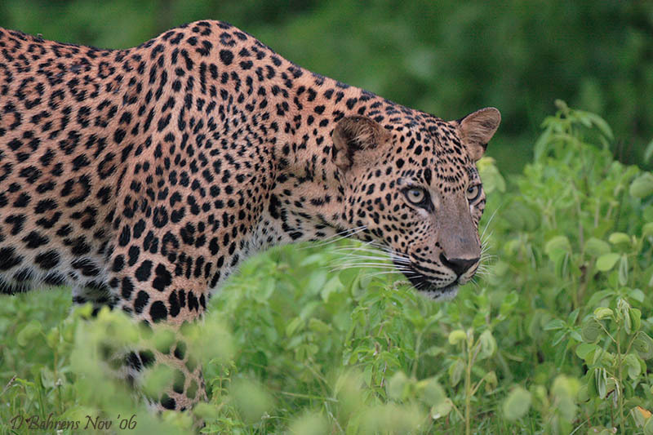
Size:
- Mass Range: 17-65 kg (37.44-143.17 lb)
- Length Range: 1.6-2.3 m (5.25-7.55 ft)

Food Habits:
- Leopards are opportunistic carnivores

Animal foods consist of:
- Birds, Mammals, Reptiles, Carrion, Mid-Size Ungulate Species, Insects,Rodents, Arthopods

Known Predators:
- Tiger (Panthera tigris)
- Lion (Panthera leo)
- Spotted hyena (Crocuta crocuta)
- African wild dog (Lycaon pictus)

David Behrens (photographer; copyright holder; identification)

Discussion Questions:

Use the included background information and the data you gathered calculating MEBF to help you answer the following questions. You may also search Animal Diversity Web for more data and information if desired.

- What are the main food habit differences between domestic and wild species? How may size affect the type of foods these species consume?

- Do the calculated bite forces correlate as expected with the size of the prey these species consume? In other words, is there a correlation between force and size?

- What are some examples of species that prey upon one another? Were there any that you found surprising? Please explain.

- Do you believe that the way species are nursed and cared for as young has anything to do with the bite forces they eventually develop? Please explain.

- Compare the MEBF you calculated for the domestic dog (gray wolf) and cat to their wild counterparts. Do you notice any differences? Can you explain any possible reasons for these differences?

- Any other interesting relationships you found within your data?

References:

Ellis, J., Thomason, J., Kebreab, E., Zubair, K., & France, J. (2009). Cranial dimensions and
forces of biting in the domestic dog. Journal Of Anatomy, 214(3), 362-373.

Thomason, J. (1991). Cranial strength in relation to estimated bite forces in some mammals.
Canadian Journal of Zoology. 69: 2326 - 2333.

Wiersma, J. (2001). Maximum Estimated Bite Force, Skull Morphology, and Primary Prey Size
in North American Carnivores. (Master’s thesis). Retrieved from Library and Archives Canada.

