**Biol 378 Mammalogy**

**Dr. Christopher Yahnke**

**University of Wisconsin – Stevens Point**

**Why Grow Big?**

Capybaras are the largest rodents living today, weighing about 60 kg. In 2003 a large fossil rodent was discovered in South America. *Phoberomys* was estimated to weigh 600 kg (Sanchez-Villagra et al., 2003). In 2008 another even larger fossil rodent was discovered and estimated to weigh 1000 kg (Rinderknecht and Blanco, 2008). At the other extreme are the harvest mice that weigh about 10 grams. When we consider the rodents in our own region, the largest rodents are the beaver and the porcupine and the smallest are the harvest mouse and deer mouse. If we take a moment to consider these extremes, we can start to generate a series of hypotheses around the question ***why grow big***?

**Q.** Working in your groups, generate a list of hypotheses to explain why some rodents like beaver, capybara, and *Phoberomys* grow so large. We’ll write these on the board before moving on.

Some of these hypotheses can be tested using **Quaardvark**. Let’s use **Quaardvark** to look at the different feeding strategies of rodents and how it correlates to size.

Research Question: Is there a relationship between the size of a rodent and their primary diet?

**Your Assignment:**

1. Predict a relationship between diet and size based on information you already learned in class.
2. Use Quaardvark to collect and analyze data. Run an Analysis of Variance (ANOVA) using SPSS. Graph the results using a line graph with 95% Confidence Intervals. Explain the trends you see.
3. Prepare a two page report to explain what you compared, what you expected, and what you found, as described in this lab.

**Setting up the Query:**

Let’s compare size in Rodents.

Begin by setting up the following query in Quaardvark:

Edit the **Animal Group** to read **Rodentia** and click Save.

Click the green **Submit** button in the lower right hand corner.

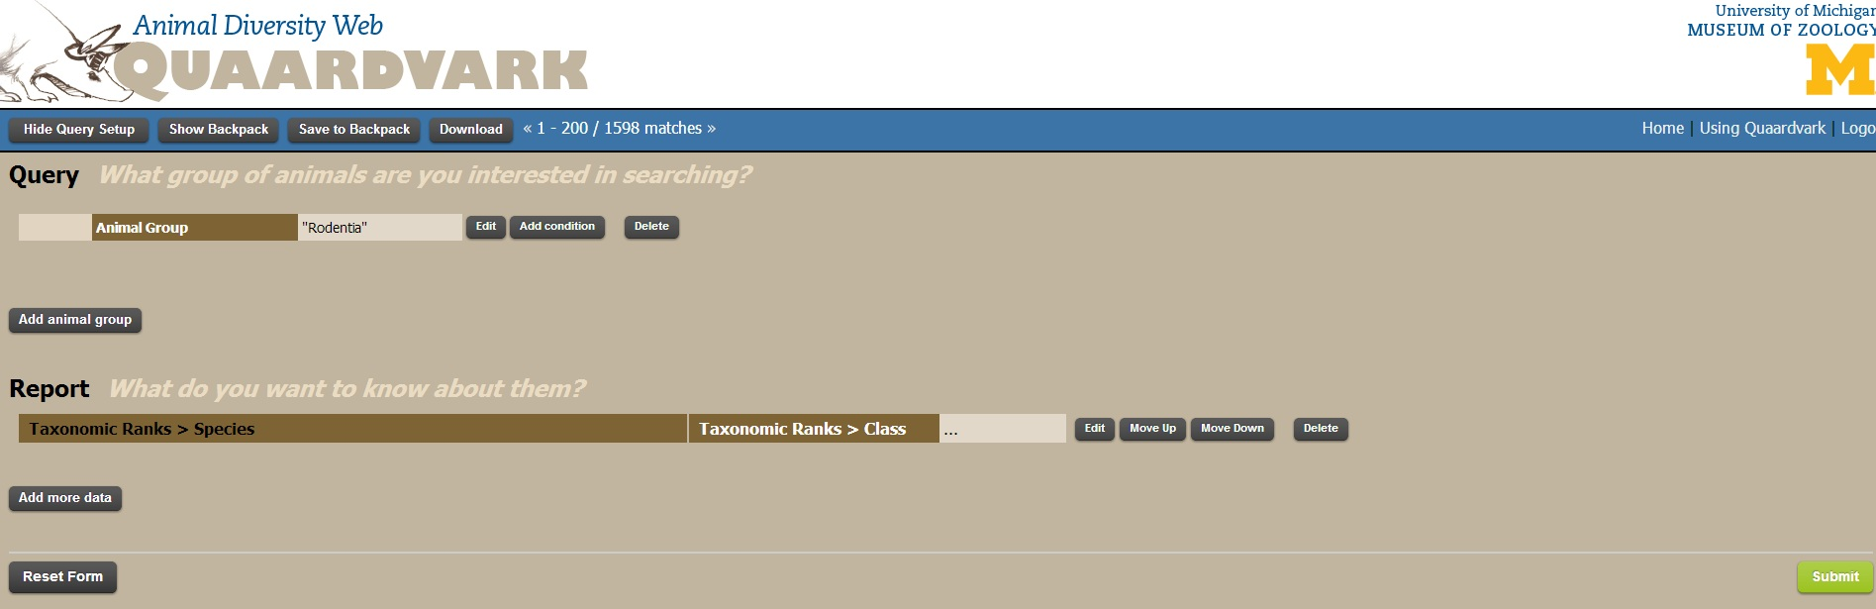

A report appears listing the rodent species in the database.

**Q: How many Rodent species are listed?**

You now have a feel for the size of the database for rodents. Next, we’ll begin the analysis of size.

You now need to figure out what to report. You will now focus on the **Report** (What do you want to know about them?) section.

Before you begin, however, you should answer the following questions:

**Q: Can you think of a measure that is reported by Quaardvark that can be used as a measure of size?**

Click the **Add more data** button. A large drop down list appears. Explore this list by clicking on one of the titles in the list. For example, click on **Habitat** or **Behavior** to see what types of data are available there.

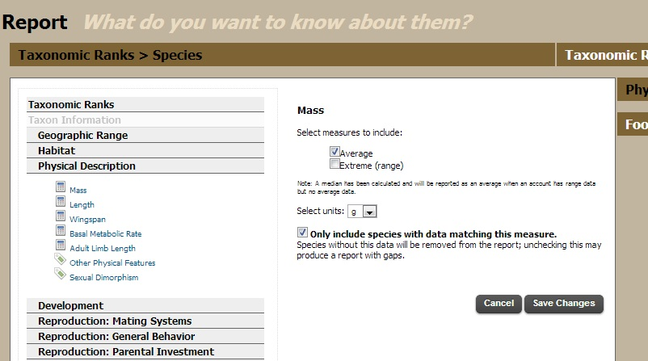When you are finished exploring, click on **Physical Description**, select **Mass** and then select measures to include **Average**. Select units **g** and select **only include species with data matching this measure**, then click the **Save Changes** button. (see figure to left)

**Q: Explain what this step accomplishes.**

Click on **Physical Description** again and select **Length**. Under the word Length select the units **mm** and select **only include species with data matching this measure**, then click the **Save Changes** button. Click **Submit**.

**Q. How many rodent species meet these criteria?**

Return to the main query page by clicking the **Show Query Setup** button.

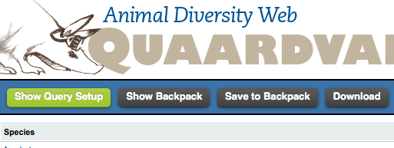

Select **Add more data**. Next click on **Food Habits** and select **Primary Diet**. Select **List keywords under a column Primary Diet** (see below). Select **Save Changes**.

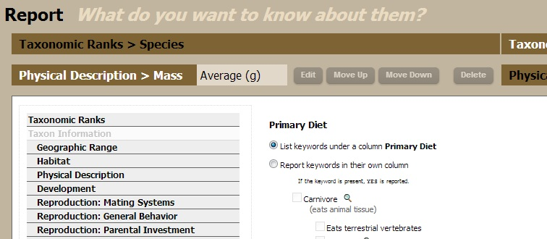

Your query should now look like the one shown below:

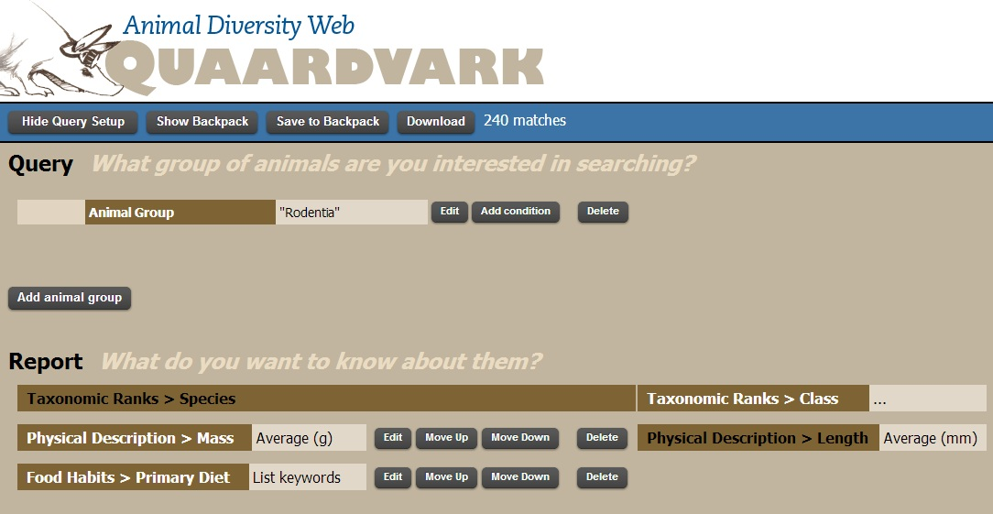

Click on the green **Submit** button to generate the report.

**Q. How many rodent species are in the final report?**

The data you requested appears in a table with columns for species name, family, mass (g), length (mm), and primary diet. A portion of the table is shown below. Save this data to your backpack. Download the data to you computer so that you can open it in Excel. If you have problems downloading the data, try using a different Internet browser like Firefox or Google Chrome.

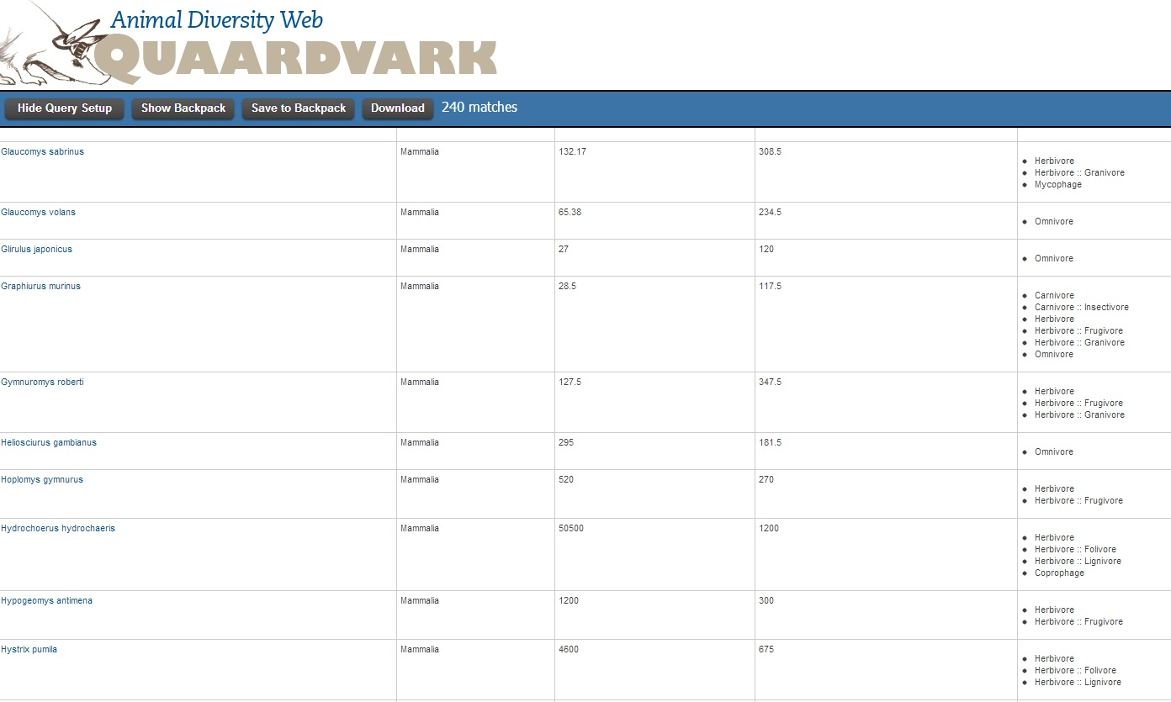

Open the data as Excel. First, create a new column labeled **Diet** and another new column labeled **Diet Code**. The need for this code will become apparent when we analyze the data using SPSS. For each entry, select a single diet category. Since multiple diet categories are listed for many species, you may need to read species accounts by selecting the links to each account in the first column above. I suggest using the following 6 classifications: Insectivore, Foliovore, Frugivore, Lignivore, Granivore, and Omnivore. Work as a group to determine which best describes the diet of each species of rodent. In the diet code column, assign a number (1-6) to each of the diet categories.

**Q: Define each of the 6 diet categories.**

**Analyzing the data using SPSS**

Open SPSS and save the file. A small portion of the data is shown below. We will test the null hypothesis that there is no size difference between rodents based on their diet. Select **Analyze**, then **Compare Means**, then **One-way ANOVA**. Select **Mass** and **Length** for **Dependent List** and select **Diet Code** for **Factor** (see below). Select **Options**, then **Descriptive Statistics**, and **Plot Means**. Select **Post Hoc**, then **Sheffe** and **S-N-K**. Select OK.

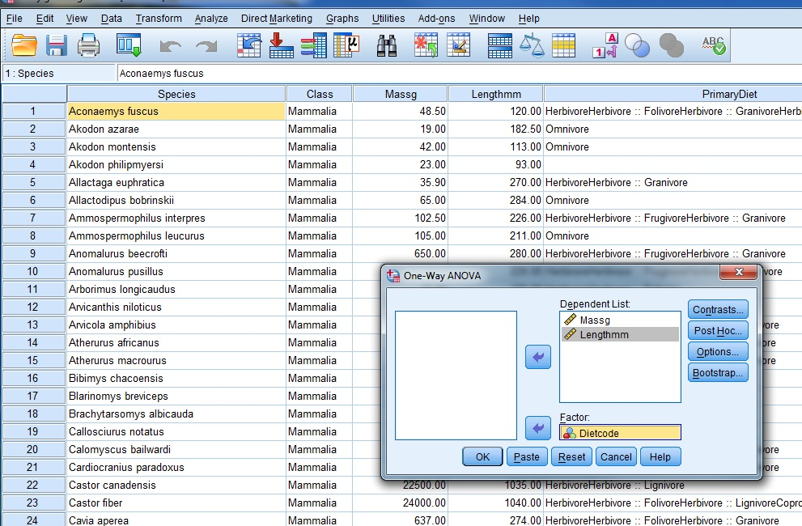

**Q: What are the means, std. errors, and ranges for mass and length for each group?**

Create a table with the mean, range, and std. error for mass and length in each diet category.

**Q: What does the mean mass and length look like graphically?**

Make a bar graph with **Mass** on the y-axis and **Diet** on the x-axis. Make another bar graph for **Length**.

**Q: How might you interpret this graph?**

**Q: Which rodents have the largest average mass and length and what is their primary diet?**

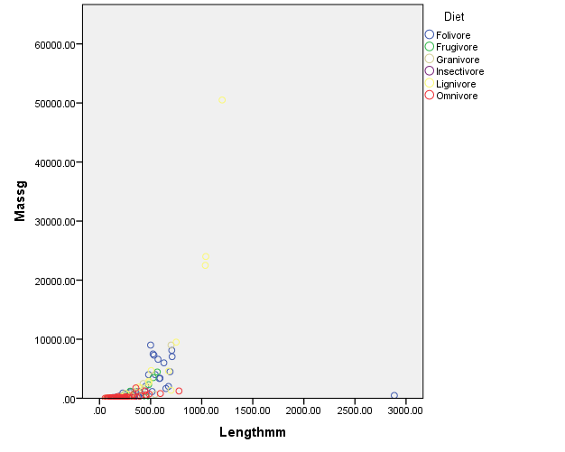**Q: Can you explain why this group of rodents would be significantly larger than the others?**

**Challenge:** You can also represent this data graphically in this fashion. How was this graph generated in SPSS?

**Q:** What information does this graph give you that the other two don’t?

Next, go back to the SPSS spreadsheet. Rerun the analysis by removing lignivores and carnivores. Answer the following questions:

**Q: How did your results change when these two groups were removed?**

**Q: Can you think of other graphs you could create to illustrate these data?**

**_________________________________________________________________________________________________________**

Rinderknecht, A., and R.E. Blanco. The largest fossil rodent. Proceedings of the Royal Society B 275:923-928.

Sanchez-Villagra et al. 2003. The anatomy of the world’s largest extinct rodent. Science 301:1708-1710.