**Convergent Evolution 1**

Distantly related organisms often develop similar adaptations when living in equivalent environments and/or possessing a comparable style of life. This trend is termed convergent evolution is widespread across mammals and other organisms and it’s very interesting to investigate to see how different organisms go about solving similar biological problems. Characters that evolved via convergent (or parallel) evolution are analogous and do not share a common ancestry. Recognizing instances of convergent evolution (and therefore recognizing analogous characters) is especially important when trying to determine relationships among organisms.

The purpose of this activity is to find examples of convergent evolution based on habitat and locomotion type in that habitat. This activity is set up as a way to explore the Quaardvark database of the Animal Diversity Web.

**Example search:**

Let’s pick a particular habitat type and compare mammals living in this habitat. Data you will report include taxonomy, key behavior, biogeographic region, primary diet, mass, key behaviors, and conservation status. You can select other topics to report as well. This particular exercise is designed to explore the Quaardvark database. If you would like to limit your output (or the number of items that are reported), you can always “**Add Condition”** under **Query**.

Login to Quaarvark (you’ll need to set up a login upon first use).

Begin by setting up the following **Query** in Quaardvark:

Under **Query**, edit the **Animal Group** to read **Mammalia** and click Save.

Click the **Add condition** button next to the Mammalia entry. A large drop down list appears. Explore this list by clicking on one of the titles in the list. For example, click on **Habitat** or **Reproduction** to see what types of data are available there.

When you are finished exploring, click on the **Habitat** title. Select **Terrestrial Biome** and then select. **Desert or dune** and then click the **Save Changes** button.

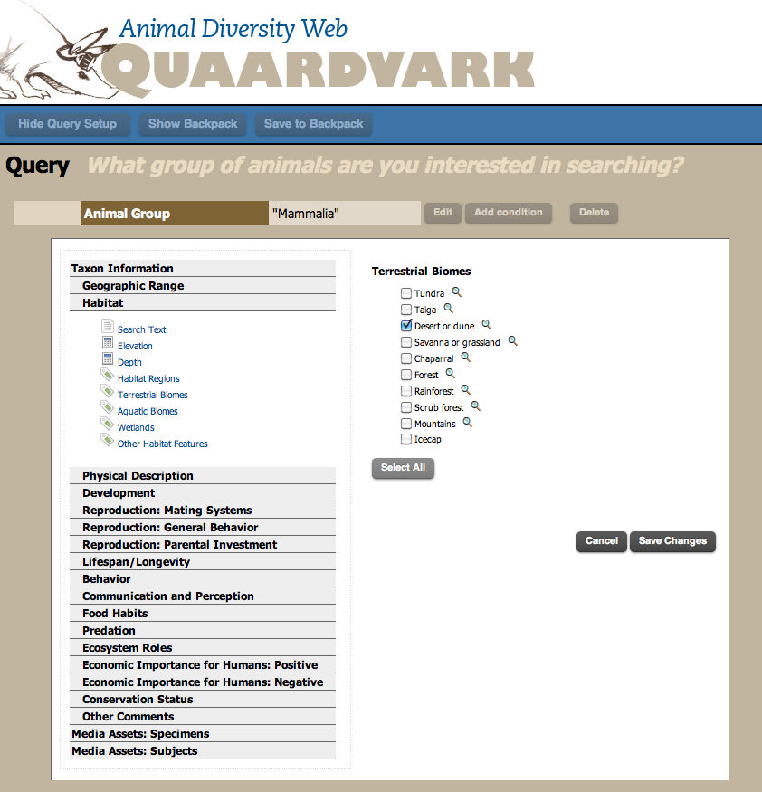

Your **Query** will look like this:

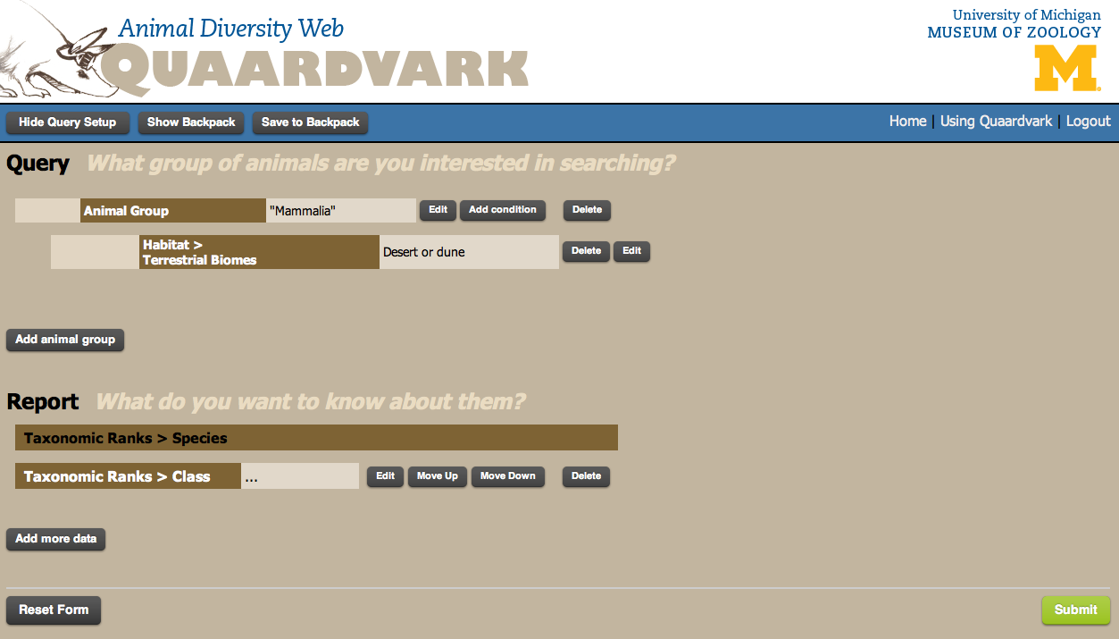

Click the green **Submit** button in the lower right hand corner. A report appears listing the mammal species in the database living in a desert or dune habitat.

**Q: How many mammal species are listed?**

Click the **Show Query Setup** in the upper left hand corner to go back to your query page.



You now have a feel for the size of the database for mammals living in a desert or dune biome. Next, we’ll begin the analysis of assessing traits that may have evolved by convergent evolution.

In your original search, *all* mammals living in a desert or dune biome are reported. But they may be quite different in size, form, and structure. You can limit your search here, if you’d like, by working with only small or large mammals. For example, click the **Add Condition** button next to your **Mammalia** entry. Click on the **Physical Description** title and select **Mass**. Under the word **Mass** to the right, select **less than** and enter **50** in the box. Keep the units as **g** and then click the **Save Changes** button. Click the green **Submit** button in the lower right hand corner. A report appears listing the mammal species in the database living in a desert or dune habitat that are less than 50g.

**Q: How many mammal species are listed now?**

Click the **Show Query Setup** in the upper left hand corner to go back to your query page. For now, let’s delete that new condition of Mass less than 50g so that we can continue to explore the database.

You now need to figure out what to report. You will now focus on the **Report** section.

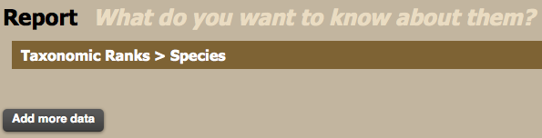

Click the **Add More Data** button.

Under Taxonomic Ranks click on **Order** and **Save Changes**.

Click the **Add More Data** button.

Under Taxonomic Ranks click on **Family** and **Save Changes**.

(note, you can also edit the **Class** setting and change that to either **Order** or **Family**)

Click the **Add More Data** button.

Under Geographic Range click on **Biogeographic Regions**. Select **Report keywords in their own column** and then **Select Native** to select the native species in all biogeographic regions. **Save Changes.**

Click the **Add More Data** button.

Under Physical Description click on **Mass**. Keep the default setting of “Average” and “g”. **Save Changes**.

Click the **Add More Data** button.

Under Behavior click on **Key Behaviors**. Select **Report keywords in their own column** and then **Select All**. **Save Changes**.

Your Report page is long, and should look something like this:

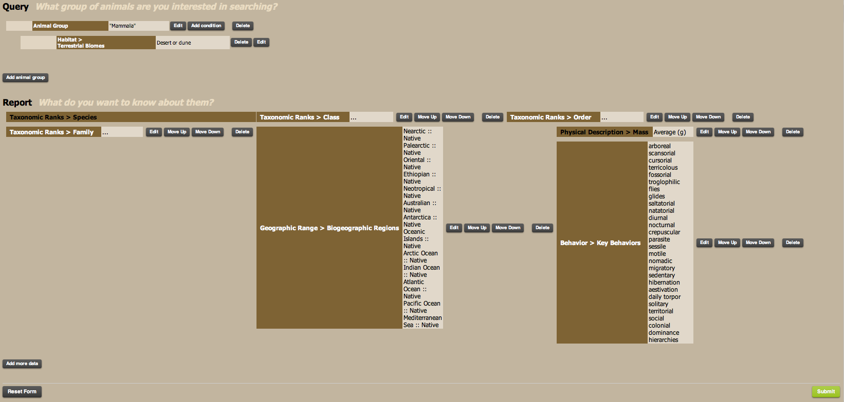

Click on the green **Submit** button to generate the report. Be patient as it may take sometime to load all the data.

The data you requested appears in a table with columns for species name, order, family, biogeographic regions, mass, etc. A small portion of the data is shown below.

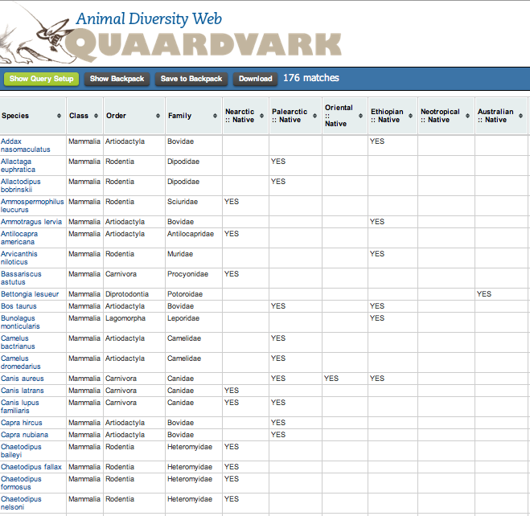

Save this data to your backpack. Click the **Download** button and open in Excel.

Once in Excel, you can sort and manipulate the data any way you would like. For example, sort by **Saltatorial** then by **Mass**. We do this particular sort because we can assume that most saltatorial species of similar size will have similar adaptations for movement across a desert biome (e.g., large hind feet for hopping/jumping). This will bring all saltatorial mammals to the top of the excel list and order them from smallest to largest. You can look at the **Family** columns and see that some species are in the same family and are closely related (likely a shared ancestry to be saltatorial) and others species are in different families and distantly related (likely similar in appearance and function via convergent evolution). For the species that belong to different families, do they occur in different biogeographic regions (**Nearctic, Palearctic, etc.**)?

**Q. Looking at saltatorial species that are less than 140g, when (during the day) are these species active? Do any of them hibernate? How many species are solitary? Taxonomically, what order do most of these species belong? What other biological similarities/differences do these species have (you can go back to Quaarvark and add in more conditions)?**

You can also sort by **Fossorial** and do a similar comparison. Alternatively, try a different **Terrestrial** or **Aquatic** biome. To determine if species of a similar size look alike/have similar adaptations possibly via convergent evolution, you can click on the species name in Quaardvark. This will take you to the Animal Diversity Web where you can read more about each species (and look at images).

Other questions: do animals possessing the same means of locomotion in a similar environment have the same body size? Does there appear to be a maximum or minimum size? What do these species tend to eat? Do activity patterns correlate with body size and what the animals eat?

**Your assignment:**

Be sure to indicate in your paper which assignment you followed or if you wrote your own. Some of these assignments were created for other classes at other Universities and are slightly edited for the purposes of this course. Remember, all assignments need to be question-driven: what question do you have about mammals? Use the Quaardvark tool to find **2 distantly related species occupying 2 different biogeographical regions** that have evolved similar morphologies via convergent evolution. You will then write a paper covering the follow items:

1) Describe how you used Quaardvark, the Animal Diversity Web, *Mammalian Species* (<http://www.science.smith.edu/departments/Biology/VHAYSSEN/msi/msiaccounts.html>), etc., to identify the **2 distantly related species occupying 2 different biogeographical regions**. You should explain how you used Quaardvark (what were your search/report terms) and how you manipulated the data output (if you did this) to better examine the data. What were your answers to the various questions in the assignment? You do not have to answer all questions; just show that you explored the database and attempted to answer some of the questions. How did you determine which two species to compare? This should be in paragraph form.

2) Compare and contrast the biology of these 2 species concentrating on their similarities and differences. Be sure to identify possible traits that may have evolved via convergent evolution (and discuss why you think a particular trait may be the result of convergent evolution). These are general questions; you should be able to come up with more for your paper. Use information from text books, reputable science resources (e.g., Animal Diversity Web and Arkive) and peer-reviewed articles to discuss these similarities and differences and/or interesting facts about your species of interest.

You will need to use a variety of sources to compare and contrast your 2 species. There are the guidelines for using peer-reviewed resources:

You will locate a minimum of **1** peer-reviewed article from a scientific journal on each of your species (to find articles use **Web of Science**, **Google Scholar**,etc.). This is a total of **2** peer-reviewed articles. Examples of appropriate journals (this is not an exclusive list; if unsure ask us if a particular journal is acceptable): *Journal of Mammalogy*, *Ecology*, *Systematic Biology*. *Journal of Wildlife Management*, *Evolution*, *American Midland Naturalist*, *Canadian Journal of Zoology*, *Southeastern Naturalist*, *Southwestern Naturalist*. *Mammalian Species* is an excellent resource for your paper. If a species account is available on one or both of your species, you should use this resource. However, these species accounts from *Mammalian Species* will not count to your minimum requirement of 2 peer-reviewed articles. Your peer-reviewed articles must be recent (within the last 15 years). Books, Internet, and websites (i.e., Wikipedia) are **not** considered to be appropriate sources. You may need to get some publications through interlibrary loans, so plan ahead.

Your paper should be 5-10 (double-spaced; 12 pt font, 1 inch margins) or 3-7 (single spaced; 12 pt font, 1 inch margins) pages. **THIS IS A ROUGH GUIDE OF PAGE NUMBERS. If you go over the maximum number of pages, that’s fine. If you’re less than the minimum, you may want to verify that you’ve completed the project and you have nothing else to write. Please do not quote from your references! Rephrase! You must list your citations in the paper, giving the full references at the end of your paper.

Reference list example (give authors, year, title, journal, volume, page numbers):

MCCORMACK, J. E., A. T. PETERSON, E. BONACCORSO, AND T. B. SMITH. 2008. Speciation in the highlands of Mexico: genetic and phenotypic divergence in the Mexican jay (Aphelocoma ultra- marina). Molecular Ecology 17:2505–2521.

RIDDLE, B. R., D. J. HAFNER, L. F. ALEXANDER, AND J. R. JAEGER. 2000. Cryptic vicariance in the historical assembly of a Baja California peninsular desert biota. Proceedings of the National Academy of Sciences 97:14438–14443.

HAFNER, D. J., AND B. R. RIDDLE. 2005. Mammalian phylogeography and evolutionary history of northern Mexico’s deserts. Pp. 225–245 in Biodiversity, ecosystems, and conservation in northern Mexico (J.-L. E. Cartron, G. Ceballos, and R. S. Felger, eds.). Oxford University Press, New York.

How to cite within the body of your paper (example; authors and year. Numerical citations are fine):

(McCormack et al. 2008)

(Riddle et al. 2000)

(Hafner and Riddle 2005)

Don’t forget the AggieHonor section in the Syllabus about Plagiarism, Copying, and Cheating:

**PLAGIARISM, COPYING, AND CHEATING:** Nothing is more destructive to science and academics than unethical duplication of others’ work. Detection of this type of dishonesty will result in zero points for the exercise, as well as summary discipline as set out in University Policy (<http://aggiehonor.tamu.edu>).