**Convergent Evolution 2**

Distantly related organisms often develop similar adaptations when living in equivalent environments and/or possessing a comparable style of life. This trend is termed convergent evolution is widespread across mammals and other organisms and it’s very interesting to investigate to see how different organisms go about solving similar biological problems. Characters that evolved via convergent (or parallel) evolution are analogous and do not share a common ancestry. Recognizing instances of convergent evolution (and therefore recognizing analogous characters) is especially important when trying to determine relationships among organisms.

The purpose of this activity is to find examples of convergent evolution between marsupial and placental mammals (or distantly related mammals within Metatheria or Eutheria). This activity is set up as a way to explore the Quaardvark database of the Animal Diversity Web.

**Example search:**

Let’s compare mammals using a particular locomotion (fossorial). Data you will report include taxonomy, key behavior, biogeographic region, primary diet, mass, key behaviors, and conservation status. You can select other topics to report as well. This particular exercise is designed to explore the Quaardvark database. If you would like to limit your output (or the number of items that are reported), you can always “**Add Condition”** under **Query**.

Begin by setting up the following **Query** in Quaardvark:

Login to Quaarvark (you’ll need to set up a login upon first use).

Under **Query**, edit the **Animal Group** to read **Mammalia** and click Save.

Click the **Add condition** button next to the Mammalia entry. A large drop down list appears. Explore this list by clicking on one of the titles in the list. For example, click on **Habitat** or **Reproduction** to see what types of data are available there.

When you are finished exploring, click on the **Behavior** title. Select **Key Behavior** and then select **Fossorial** and then click the **Save Changes** button.

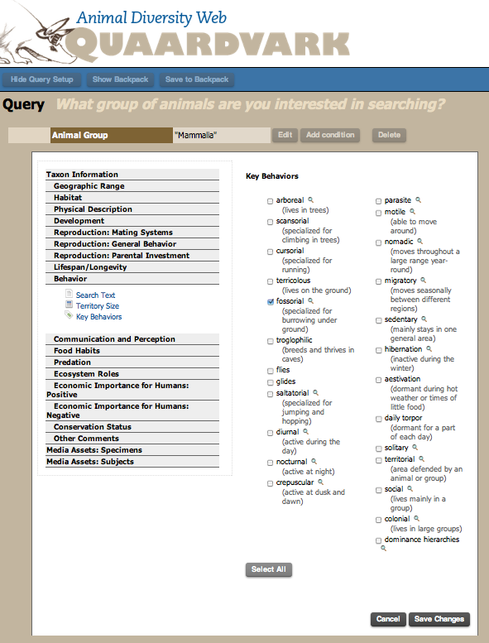

Your **Query** will look like this:

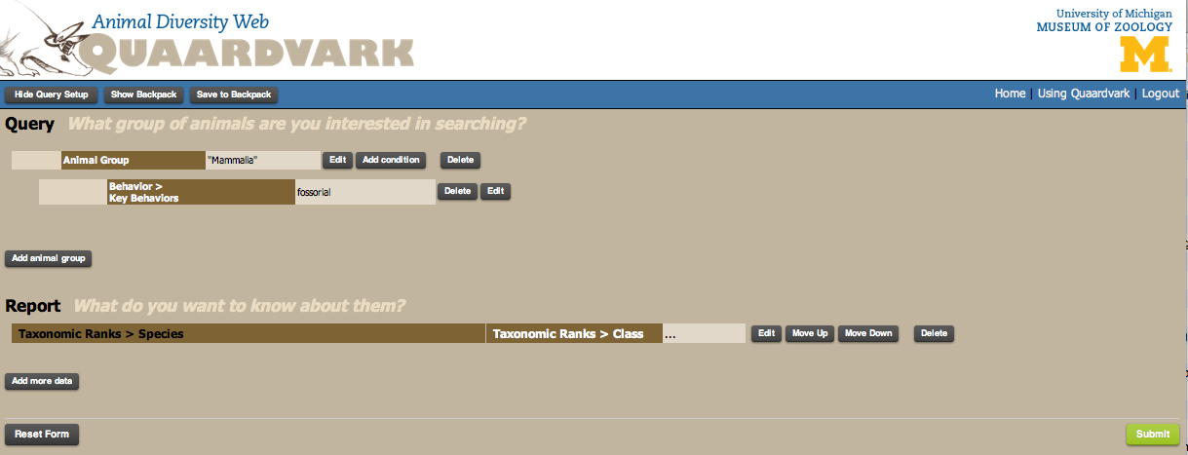

Click the green **Submit** button in the lower right hand corner. A report appears listing the mammal species in the database that are carnivores.

**Q: How many mammal species are listed?**

Click the **Show Query Setup** in the upper left hand corner to go back to your query page.



You now have a feel for the size of the database for mammals that are fossorial. Next, we’ll begin the analysis of assessing whether or not fossoriality (and other traits) may have evolved by convergent evolution.

In your original search, *all* mammals that are fossorial are reported. But they may be quite different in size, form, and structure. You can limit your search here, if you’d like, by working with only small or large mammals. For example, click the **Add Condition** button next to your **Mammalia** entry. Click on the **Physical Description** title and select **Mass**. Under the word **Mass** to the right, select **less than** and enter **250** in the box. Keep the units as **g** and then click the **Save Changes** button. Click the green **Submit** button in the lower right hand corner. A report appears listing the mammal species in the database that are fossorial and less than 250g.

**Q: How many mammal species are listed now?**

Click the **Show Query Setup** in the upper left hand corner to go back to your query page. For now, let’s delete that new condition of Mass less than 250g so that we can continue to explore the database.

You now need to figure out what to report. You will now focus on the **Report** section.



Click the **edit** button next to “Taxonomic Ranks > Class”. Click on **Order** and **Save Changes.**

Click the **Add More Data** button.

Under Taxonomic Ranks click on **Family** and **Save Changes**.

Click the **Add More Data** button.

Under Geographic Range click on **Biogeographic Regions**. Select **Report keywords in their own column** and then **Select Native** to select the native species in all biogeographic regions. **Save Changes.**

Click the **Add More Data** button.

Under Physical Description click on **Mass**. Keep the default setting of “Average” and “g”. **Save Changes**.

Click the **Add More Data** button.

Under Behavior click on **Key Behaviors**. Select **Report keywords in their own column** and then **Select All**. **Save Changes**.

Your Report page is long, and should look something like this:

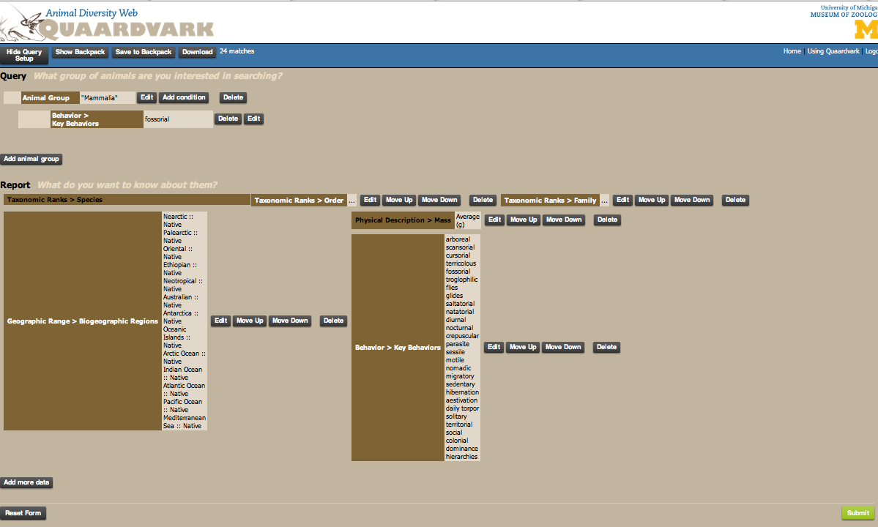

Click on the green **Submit** button to generate the report. Be patient as it may take sometime to load all the data.

The data you requested appears in a table with columns for species name, order, family, biogeographic regions, mass, etc. A small portion of the data is shown below.

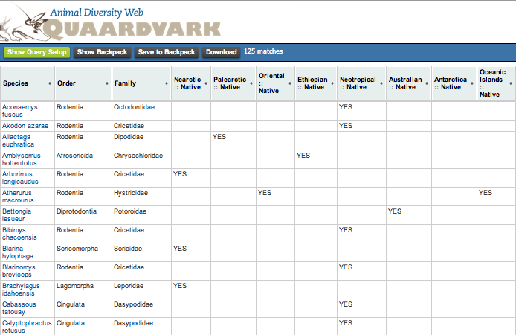

Save this data to your backpack. Click the **Download** button and open in Excel.

Once in Excel, you can sort and manipulate the data any way you would like. For example, sort by **Fossorial** then by **Mass**. Can you find a marsupial and a placental mammal that are similar in size (within 50 g of each other) and both fossorial? What about distantly related fossorial placental mammals? Do these 2 species possess similar traits beyond being fossorial and an insectivore? Read about these 2 species using the Animal Diversity Web (each species is linked to that ADW in Quaardvark). Where doe these species occur? When (during the day) are these species active? Do any of them hibernate? How many species are solitary? Taxonomically, what orders do most of these species belong? What other biological similarities/differences do these species have (you can go back to Quaarvark and add in more conditions)? Look at your excel sheet closely – do you see species that you know are fossorial but are missing from the output? Why would that be?

You can also do a similar search on **Gliding** or other means of locomotion (or diet, etc).

**Your assignment:**

Be sure to indicate in your paper which assignment you followed or if you wrote your own. Some of these assignments were created for other classes at other Universities and are slightly edited for the purposes of this course. Remember, all assignments need to be question-driven: what question do you have about mammals? Use the Quaardvark tool to find **2 distantly related species (a marsupial and a placental mammal or some other distantly related pair)** that are both similar in some way (such as being fossorial) and likely have developed similar morphologies via convergent evolution. You will then write a paper covering the follow items:

1) Describe how you used Quaardvark, the Animal Diversity Web, *Mammalian Species* (<http://www.science.smith.edu/departments/Biology/VHAYSSEN/msi/msiaccounts.html>), etc., to identify the **2 distantly related species occupying 2 different biogeographical regions**. You should explain how you used Quaardvark (what were your search/report terms) and how you manipulated the data output (if you did this) to better examine the data. What were your answers to the various questions in the assignment? You do not have to answer all questions; just show that you explored the database and attempted to answer some of the questions. How did you determine which two species to compare? This should be in paragraph form.

2) Compare and contrast the biology of these 2 species concentrating on their similarities and differences. Be sure to identify possible traits that may have evolved via convergent evolution (and discuss why you think a particular trait may be the result of convergent evolution). These are general questions; you should be able to come up with more for your paper. Use information from text books, reputable science resources (e.g., Animal Diversity Web and Arkive), and peer-reviewed articles to discuss these similarities and differences and/or interesting facts about your species of interest.

You will need to use a variety of sources to compare and contrast your 2 species. There are the guidelines for using peer-reviewed resources:

You will locate a minimum of **1** peer-reviewed article from a scientific journal on each of your species (to find articles use **Web of Science**, **Google Scholar**,etc.). This is a total of **2** peer-reviewed articles. Examples of appropriate journals (this is not an exclusive list; if unsure ask us if a particular journal is acceptable): *Journal of Mammalogy*, *Ecology*, *Systematic Biology*. *Journal of Wildlife Management*, *Evolution*, *American Midland Naturalist*, *Canadian Journal of Zoology*, *Southeastern Naturalist*, *Southwestern Naturalist*. *Mammalian Species* is an excellent resource for your paper. If a species account is available on one or both of your species, you should use this resource. However, these species accounts from *Mammalian Species* will not count to your minimum requirement of 2 peer-reviewed articles. Your peer-reviewed articles must be recent (within the last 15 years). Books, Internet, and websites (i.e., Wikipedia) are **not** considered to be appropriate sources. You may need to get some publications through interlibrary loans, so plan ahead.

Your paper should be 5-10 (double-spaced; 12 pt font, 1 inch margins) or 3-7 (single spaced; 12 pt font, 1 inch margins) pages. **THIS IS A ROUGH GUIDE OF PAGE NUMBERS. If you go over the maximum number of pages, that’s fine. If you’re less than the minimum, you may want to verify that you’ve completed the project and you have nothing else to write. Please do not quote from your references! Rephrase! You must list your citations in the paper, giving the full references at the end of your paper.

Reference list example (give authors, year, title, journal, volume, page numbers):

MCCORMACK, J. E., A. T. PETERSON, E. BONACCORSO, AND T. B. SMITH. 2008. Speciation in the highlands of Mexico: genetic and phenotypic divergence in the Mexican jay (Aphelocoma ultra- marina). Molecular Ecology 17:2505–2521.

RIDDLE, B. R., D. J. HAFNER, L. F. ALEXANDER, AND J. R. JAEGER. 2000. Cryptic vicariance in the historical assembly of a Baja California peninsular desert biota. Proceedings of the National Academy of Sciences 97:14438–14443.

HAFNER, D. J., AND B. R. RIDDLE. 2005. Mammalian phylogeography and evolutionary history of northern Mexico’s deserts. Pp. 225–245 in Biodiversity, ecosystems, and conservation in northern Mexico (J.-L. E. Cartron, G. Ceballos, and R. S. Felger, eds.). Oxford University Press, New York.

How to cite within the body of your paper (example; authors and year. Numerical citations are fine):

(McCormack et al. 2008)

(Riddle et al. 2000)

(Hafner and Riddle 2005)

Don’t forget the AggieHonor section in the Syllabus about Plagiarism, Copying, and Cheating:

**PLAGIARISM, COPYING, AND CHEATING:** Nothing is more destructive to science and academics than unethical duplication of others’ work. Detection of this type of dishonesty will result in zero points for the exercise, as well as summary discipline as set out in University Policy (<http://aggiehonor.tamu.edu>).