**Water and Body Size**

The purpose of this activity is to see if there is a correlation between body size of primarily aquatic mammals and latitude. This activity is set up as a way to explore the Quaardvark database of the Animal Diversity Web.

**Example search:**

Let’s pick a mammal groups to compare. Data you will report include mass, latitude, feeding behavior, and other topics you may find interesting. This particular exercise is designed to explore the Quaardvark database, and this is an example! I highly recommend you run the search using slightly different queries and reports.

Login to Quaarvark (you’ll need to set up a login upon first use).

Begin by setting up the following **Query** in Quaardvark:

Under **Query**, edit the **Animal Group** to read **Cetacea** and click Save.

Click the **Add animal group** button below the Mammalia entry. Add **Sirenia**, **Otariidae**, **Phocidae**, and **Odobenidae**.

Next, you need to figure out what to report. You will now focus on the **Report** section.

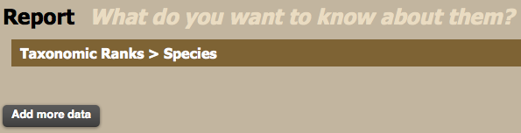

Next to **Taxonomic Ranks > Class** click edit and select **Family**

Click the **Add More Data** button.

Under Geographic Range click on **Biogeographic Regions**. Select **Report keywords in their own column** and then **Select Native** to select the native species in all biogeographic regions. **Save Changes.**

Click the **Add More Data** button.

Under Physical Description click on **Mass**. Keep the default setting of “Average” and “kg”. **Save Changes**.

Click the **Add More Data** button.

Under Physical Description click on **Length**. Keep the default setting of “Average” and change the units to “m”. **Save Changes**.

Click the **Add More Data** button.

Under Food Habits click on **Primary Diet**. Select **Report keywords in their own column** and then **Select All** and **Save Changes**.

**Q: What else can you report on? What kinds of things can you report with Lifespan? Reproduction? Development? Depth?**

Click the green **Submit** button in the lower right hand corner. A report appears listing the mammal species in the database living in rainforests or savannas/grasslands.

**Q: How many mammal species are listed?**

The data you requested appears in a table with columns for species name, order, family, biogeographic regions, mass, etc. A small portion of the data is shown below.

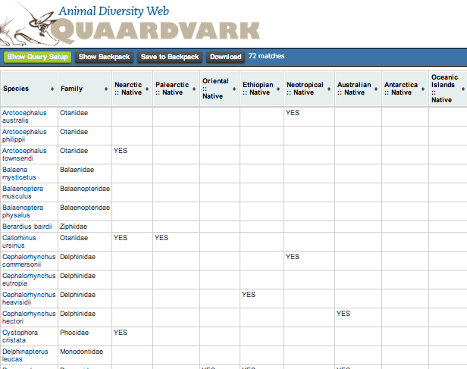

Save this data to your backpack. Click the **Download** button and open in Excel.

Once in Excel, you can sort and manipulate the data any way you would like. For example, sort by **Mass**.

**Questions:**

How many families/genera/species are found in the Arctic or Antarctic? What is their average body size (mass and/or length)? How many families/genera/species are found in more tropical waters? What is their average body size (mass and/or length)? Are there any trends in key behaviors/food preferences/etc. correlated with region? Does there appear to be a minimum size depending on where the organism is found (cold vs warm water)? Are there certain food types associated with particular types of water? Is there a trend regarding where baleen whales are found?

To answer some of the above questions, you can make plots or bar graphs in excel.

**Your assignment:**

Be sure to indicate in your paper which assignment you followed or if you wrote your own. Some of these assignments were created for other classes at other Universities and are slightly edited for the purposes of this course. Remember, all assignments need to be question-driven: what question do you have about mammals? Use the Quaardvark tool to find **2 species (1 small and 1 large for this particular exercise)** to help answer this question. You will then write a paper covering the follow items:

1) Describe how you used Quaardvark, the Animal Diversity Web, *Mammalian Species* (<http://www.science.smith.edu/departments/Biology/VHAYSSEN/msi/msiaccounts.html>), etc., to identify the **2 species, 1 small and 1 large**. You should explain how you used Quaardvark (what were your search/report terms) and how you manipulated the data output (if you did this) to better examine the data. What were your answers to the various questions in the assignment? You do not have to answer all questions; just show that you explored the database and attempted to answer some of the questions. How did you determine which two species to compare? This should be in paragraph form.

2) Compare and contrast the biology of these 2 species. How do they each survive and use the environment they are found in? How do their body sizes differ? These are general questions; you should be able to come up with more for your paper. Use information from text books, reputable science resources (e.g., Animal Diversity Web and Arkive), and peer-reviewed articles to discuss these similarities and differences and/or interesting facts about your species of interest.

You will need to use a variety of sources to compare and contrast your 2 species. There are the guidelines for using peer-reviewed resources:

You will locate a minimum of **1** peer-reviewed article from a scientific journal on each of your species (to find articles use **Web of Science**, **Google Scholar**,etc.). This is a total of **2** peer-reviewed articles. Examples of appropriate journals (this is not an exclusive list; if unsure ask us if a particular journal is acceptable): *Journal of Mammalogy*, *Ecology*, *Systematic Biology*. *Journal of Wildlife Management*, *Evolution*, *American Midland Naturalist*, *Canadian Journal of Zoology*, *Southeastern Naturalist*, *Southwestern Naturalist*. *Mammalian Species* is an excellent resource for your paper. If a species account is available on one or both of your species, you should use this resource. However, these species accounts from *Mammalian Species* will not count to your minimum requirement of 2 peer-reviewed articles. Your peer-reviewed articles must be recent (within the last 15 years). Books, Internet, and websites (i.e., Wikipedia) are **not** considered to be appropriate sources. You may need to get some publications through interlibrary loans, so plan ahead.

Your paper should be 5-10 (double-spaced; 12 pt font, 1 inch margins) or 3-7 (single spaced; 12 pt font, 1 inch margins) pages. **THIS IS A ROUGH GUIDE OF PAGE NUMBERS. If you go over the maximum number of pages, that’s fine. If you’re less than the minimum, you may want to verify that you’ve completed the project and you have nothing else to write. Please do not quote from your references! Rephrase! You must list your citations in the paper, giving the full references at the end of your paper.

Reference list example (give authors, year, title, journal, volume, page numbers):

MCCORMACK, J. E., A. T. PETERSON, E. BONACCORSO, AND T. B. SMITH. 2008. Speciation in the highlands of Mexico: genetic and phenotypic divergence in the Mexican jay (Aphelocoma ultra- marina). Molecular Ecology 17:2505–2521.

RIDDLE, B. R., D. J. HAFNER, L. F. ALEXANDER, AND J. R. JAEGER. 2000. Cryptic vicariance in the historical assembly of a Baja California peninsular desert biota. Proceedings of the National Academy of Sciences 97:14438–14443.

HAFNER, D. J., AND B. R. RIDDLE. 2005. Mammalian phylogeography and evolutionary history of northern Mexico’s deserts. Pp. 225–245 in Biodiversity, ecosystems, and conservation in northern Mexico (J.-L. E. Cartron, G. Ceballos, and R. S. Felger, eds.). Oxford University Press, New York.

How to cite within the body of your paper (example; authors and year. Numerical citations are fine):

(McCormack et al. 2008)

(Riddle et al. 2000)

(Hafner and Riddle 2005)

Don’t forget the AggieHonor section in the Syllabus about Plagiarism, Copying, and Cheating:

**PLAGIARISM, COPYING, AND CHEATING:** Nothing is more destructive to science and academics than unethical duplication of others’ work. Detection of this type of dishonesty will result in zero points for the exercise, as well as summary discipline as set out in University Policy (<http://aggiehonor.tamu.edu>).