**Sexual dimorphisms and reproduction type**

The purpose of this activity is to explore sexual dimorphism within an Order or Family, and correlate it to type of reproduction (monogamous, polygynous, etc.), number of offspring, lifespan, and key behavior. This activity is set up as a way to explore the Quaardvark database of the Animal Diversity Web.

**Example search:**

Let’s pick a mammal group to explore. Data you will report include mass, length, sexual dimorphism, mating system, key behaviors, and other topics you may find interesting. This particular exercise is designed to explore the Quaardvark database, and this is an example! I highly recommend you run the search using slightly different queries and reports.

Login to Quaarvark (you’ll need to set up a login upon first use).

Begin by setting up the following **Query** in Quaardvark:

Under **Query**, edit the **Animal Group** to read **Carnivora** and click Save.

Click **Add Condition.** Under **Physical Description** and **Sexual Dimorphism**, select the following: **Female larger, male larger, sexes colored or patterned differently, female more colorful, male more colorful,** and **sexes shaped differently.** Click **Save changes.**

Next, you need to figure out what to report. You will now focus on the **Report** section.

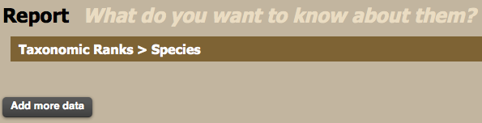

Next to **Taxonomic Ranks > Class** click edit and select **Family. Save Changes.**

Click the **Add More Data** button.

Under Reproduction: Mating Systems click on **Mating Systems**. Select **report keywords in their own column**, **Select All**, and then **Save Changes.**

Click the **Add More Data** button.

Under **Physical Description** and **Sexual Dimorphism**, Select **report keywords in their own column** and click: **Female larger, male larger, sexes colored or patterned differently, female more colorful, male more colorful,** and **sexes shaped differently.** Click **Save changes**

Click the **Add More Data** button.

Under Reproduction: General Behavior click on **Number of Offspring**. You can leave the default settings (average). **Save Changes**.

Click the **Add More Data** button.

Under Lifespan/Longevity click on **Lifespan wild (undetermined, male, and female)**. You can leave the default settings but be sure to unclick ‘only include species with data matching this measure.’ **Save Changes**.

Click the **Add More Data** button.

Under Behavior click on **Key Behaviors**. Select **Report keywords in their own column** and then select **solitary, territorial, social, colonial, and dominance hierarchies. Save Changes**.

**Q: What else can you report on? Are there other key behaviors or general behaviors?**

This is what your query page will look something like this:

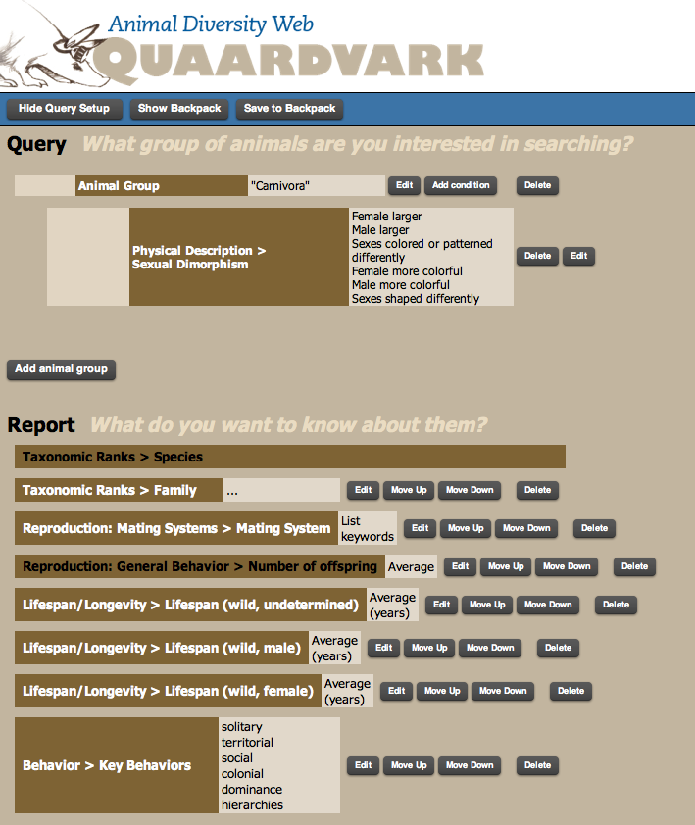

Click the green **Submit** button in the lower right hand corner.

**Q: How many mammal species are listed?**

The data you requested appears in a table with columns for species name, family, mass, sexual dimorphism, etc. A small portion of the data is shown below.

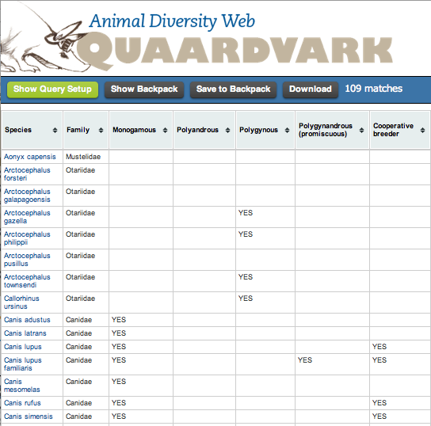

Save this data to your backpack. Click the **Download** button and open in Excel.

Once in Excel, you can sort and manipulate the data any way you would like. For example, sort by **Female Larger** and then **Male Larger**.

**Questions:**

How many species have females larger than males or males larger than females? What mating systems are associated with each type of dimorphism? Are there any behaviors that appear to correlate with a mating system or type of dimorphism? Are there any correlations with number of offspring or lifespan? What about key behaviors?

To answer some of the above questions, you can make plots or bar graphs in excel.

**Your assignment:**

Be sure to indicate in your paper which assignment you followed or if you wrote your own. Some of these assignments were created for other classes at other Universities and are slightly edited for the purposes of this course. Remember, all assignments need to be question-driven: what question do you have about mammals? Use the Quaardvark tool to find **2 species, one with males larger than females and one with females larger than males**. Make sure that your 2 species also differ in mating system (monogamous, polygynous, etc). You will then write a paper covering the follow items:

1) Describe how you used Quaardvark, the Animal Diversity Web, *Mammalian Species* (<http://www.science.smith.edu/departments/Biology/VHAYSSEN/msi/msiaccounts.html>), etc., to identify the **2 species**. You should explain how you used Quaardvark (what were your search/report terms) and how you manipulated the data output (if you did this) to better examine the data. What were your answers to the various questions in the assignment? You do not have to answer all questions; just show that you explored the database and attempted to answer some of the questions. How did you determine which two species to compare? This should be in paragraph form.

2) Compare and contrast the biology of these 2 species. For example, how do their mating systems, key behaviors, etc., differ? These are general questions; you should be able to come up with more for your paper. Use information from text books, reputable science resources (e.g., Animal Diversity Web and Arkive), and peer-reviewed articles to discuss these similarities and differences and/or interesting facts about your species of interest.

You will need to use a variety of sources to compare and contrast your 2 species. There are the guidelines for using peer-reviewed resources:

You will locate a minimum of **1** peer-reviewed article from a scientific journal on each of your species (to find articles use **Web of Science**, **Google Scholar**,etc.). This is a total of **2** peer-reviewed articles. Examples of appropriate journals (this is not an exclusive list; if unsure ask us if a particular journal is acceptable): *Journal of Mammalogy*, *Ecology*, *Systematic Biology*. *Journal of Wildlife Management*, *Evolution*, *American Midland Naturalist*, *Canadian Journal of Zoology*, *Southeastern Naturalist*, *Southwestern Naturalist*. *Mammalian Species* is an excellent resource for your paper. If a species account is available on one or both of your species, you should use this resource. However, these species accounts from *Mammalian Species* will not count to your minimum requirement of 2 peer-reviewed articles. Your peer-reviewed articles must be recent (within the last 15 years). Books, Internet, and websites (i.e., Wikipedia) are **not** considered to be appropriate sources. You may need to get some publications through interlibrary loans, so plan ahead.

Your paper should be 5-10 (double-spaced; 12 pt font, 1 inch margins) or 3-7 (single spaced; 12 pt font, 1 inch margins) pages. **THIS IS A ROUGH GUIDE OF PAGE NUMBERS. If you go over the maximum number of pages, that’s fine. If you’re less than the minimum, you may want to verify that you’ve completed the project and you have nothing else to write. Please do not quote from your references! Rephrase! You must list your citations in the paper, giving the full references at the end of your paper.

Reference list example (give authors, year, title, journal, volume, page numbers):

MCCORMACK, J. E., A. T. PETERSON, E. BONACCORSO, AND T. B. SMITH. 2008. Speciation in the highlands of Mexico: genetic and phenotypic divergence in the Mexican jay (Aphelocoma ultra- marina). Molecular Ecology 17:2505–2521.

RIDDLE, B. R., D. J. HAFNER, L. F. ALEXANDER, AND J. R. JAEGER. 2000. Cryptic vicariance in the historical assembly of a Baja California peninsular desert biota. Proceedings of the National Academy of Sciences 97:14438–14443.

HAFNER, D. J., AND B. R. RIDDLE. 2005. Mammalian phylogeography and evolutionary history of northern Mexico’s deserts. Pp. 225–245 in Biodiversity, ecosystems, and conservation in northern Mexico (J.-L. E. Cartron, G. Ceballos, and R. S. Felger, eds.). Oxford University Press, New York.

How to cite within the body of your paper (example; authors and year. Numerical citations are fine):

(McCormack et al. 2008)

(Riddle et al. 2000)

(Hafner and Riddle 2005)

Don’t forget the AggieHonor section in the Syllabus about Plagiarism, Copying, and Cheating:

**PLAGIARISM, COPYING, AND CHEATING:** Nothing is more destructive to science and academics than unethical duplication of others’ work. Detection of this type of dishonesty will result in zero points for the exercise, as well as summary discipline as set out in University Policy (<http://aggiehonor.tamu.edu>).