How does community structure differ in terrestrial and aquatic habitats?

http://animaldiversity.ummz.umich.edu/quaardvark/

In this exercise you’ll be exploring trophic interactions in two very structurally different kinds of habitats: terrestrial grasslands and aquatic lakes and ponds. The goal is characterize some major differences in food webs/trophic interactions, taxonomic makeup of those communities, and the kinds of feeding styles that dominate in each system. You may also wish to consider the impact of biases in the Animal Diversity Web database on your results. For historical reasons, the Animal Diversity Web (ADW) is biased towards mammals and North American faunas.
You will use the data querying tool of the ADW to extract information on animals in these two kinds of habitats for comparison. To correct for the ADW bias towards North American faunas, you’ll restrict your search to the Nearctic (North American) region.
Go to the ADW querying interface (link above). You will have to register to be able to use all of its features for your course. Once you register (directions are on the site), you can log in and begin your query.
Go to the “Search and Report” page. On this page you’ll be able to construct the query: a search (what set of animals you’d like it to recover) and the report (what data about those animals you’d like to see).

Query 1: Terrestrial
Query first for:
Animal Group = Animalia,
Add Condition: Biogeographic Region: Nearctic (native): save changes.
Add Condition: Habitat (Terrestrial Biomes): Savanna or grassland: save changes.

Build the report to include:
1) Species Name (this is there by default)
2) Class (the taxon at the Class level, so Mammalia, Reptilia, etc.) (this is also there by default)
3) Add more data: Food Habits: Primary Diet: List keywords: Save Changes
4) Add more data: Predation: Known Predators : Save Changes

Select “Submit” and wait for the results to appear. Once that is complete you can “Save to Backpack” in order to save your work in your personal space on Quaardvark. You should also “Download” the report to your desktop, where you can open it in Excel or other statistics programs.

Query 2: Aquatic
Repeat these steps to create a second query and report. You can do this also by simply modifying your first request. All you will need to change is one of the Query conditions (in the top section – edit the habitat line). If you want to do it the long way, here are the steps you need:

Query for:
Animal Group = Animalia,
Add condition: Biogeographic Region: Nearctic (native): Save Changes.
Add condition: Habitat: Aquatic Biomes: Lakes and Ponds. Save Changes.

Build the second report to give you the identical kinds of information as the first report.
1) Species Name (this is there by default)
2) Class (the taxon at the Class level, so Mammalia, Reptilia, etc.) (this is also there by default)
3) Add more data: Food Habits: Primary Diet: List keywords: Save Changes
4) Add more data: Predation: Known Predators : Save Changes

Download the report to your desktop.

Once you have two report spreadsheets on your desktop, open them in Excel and start by weeding out entries with incomplete data. (ADW species with incomplete data are also an historical artifact. Our previous species account templates were not as complex as they currently are, and not all of the information that we currently include was reported in older accounts. We continue to try to update accounts, but aren’t anywhere near done!)

Click on the <> in the upper left corner of each spreadsheet to select all cells, then go to the “Data” menu and select “Sort.” Sort by Primary Diet and then by Predators. You should find that all entries with no primary diet or predators are grouped and you can select and delete them. When you’ve done this for both spreadsheets, you should have only entries with both primary diet and predator information.
Sort the spreadsheets again by clicking on the <> and selecting “Sort” from the “Data” menu. This time sort by Primary Diet, then by Class, and finally by Species. Once this is complete, you should have two sets of data for asking a set of questions about trophic structure in different habitats and for building two food webs to explore interactions.

- How does the relative diversity of carnivores, herbivores, and omnivores differ between these aquatic and terrestrial habitats?

- Are there dietary strategies in aquatic systems that are not available in terrestrial systems? Explain how that might impact the relative diversity of carnivores, herbivores, omnivores, and other primary dietary strategies in the aquatic system.

- Are there differences in the relative diversity of animal groups (Classes) in each system? Explain why this might be the case.

- Energy flow models in ecological communities are sometimes represented as an “energy pyramid,” with much larger numbers of herbivores in any community than carnivores. For example:
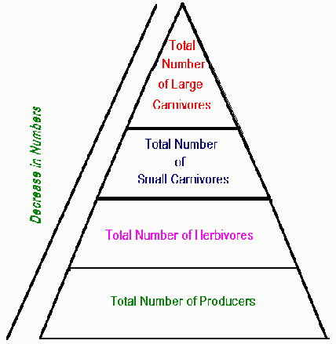
Explain how the relative diversity of carnivores and herbivores you calculated in Question 1 is related, or not, to this energy pyramid model.

5. Use the data in your spreadsheets to create two food webs, one for the terrestrial system and one for the aquatic system. Don’t try to use all of the animals (10-20 is a good target), but do try to build a food web that spans all of the trophic levels.
a. Are there animals that are shared between the two ecological systems?
b. What are the primary similarities and differences in trophic interactions in these aquatic and terrestrial habitats?

6. How might ADW data bias have impacted your results?

