- First, consider the question: What is the expected relationship between mating systems and whether or not there is sexual dimorphism in a species?

- Go to the “search and report” page, http://animaldiversity.ummz.umich.edu/quaardvark/search/. Make sure you are logged in so you can download data.

- In the Query section:
  - Edit the “Animal Group” section to read “Cercopithecidae”. Do this by typing “Cer” into the box, wait for a list of possible matches to appear, then select “Cercopithecidae” (see this page for what that group includes: http://animaldiversity.ummz.umich.edu/site/accounts/classification/Cercopithecidae.html#Cercopithecidae)
  - Click the Add condition button, then go to Geographic Range, select Biogeographic Regions, and click on Ethiopian. This will restrict your results to only those members of the family Cercopithecidae that occur in Africa. Click on Save Changes.
  - Click “Add Animal Group,” add Hominidae in the same way as above. Type “Hom” and then wait for the list of possible matches to appear and select Hominidae. The term that joins those two taxon names should be “OR.”
  - As in b, above, add the condition “Ethiopian” so that you restrict your results to only those hominids that occur in Africa.
  - In the same way as above, add the family Galagidae. However, you don’t need to restrict those results to Ethiopian, as members of that family all occur in Africa. Your query should look like this:
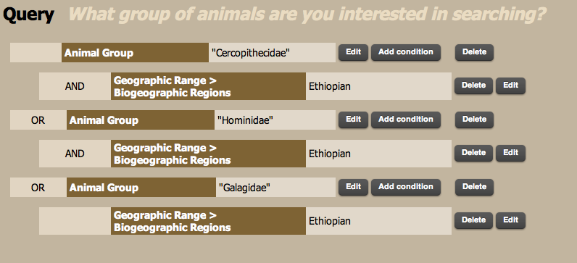

- In the Report section:
  - Edit the default taxonomic ranks field to read Family rather than Class.
  - Click on the Add more data button. Scroll down to Physical Description and select it, you’ll then see another list to choose from. Click on Sexual Dimorphism. The default is to list all sexual dimorphism keywords under a column of that heading. You can keep this, or you can choose to have several sexual dimorphism keywords reported in their own column. The most relevant keywords will be female larger, male larger, and sexes colored or patterned differently.
  - Again, click Add more data then scroll to Reproduction: Mating Systems. Click on Mating Systems and list keywords under a column by that name or in separate columns. Here we’ll be looking mainly for the relative incidence of monogamy and polygyny.
  - Click Add more data then scroll Media Assets: Specimens. This is the section where you can choose various specimen images. (Suggestion: skull – ventral & lateral; both lower jaw views.) For this query, choose skulls and make sure that you de-select the box that says “only include species with media assets matching this terms.” One issue you’ll want to consider is that we won’t necessarily have skull images for both females and males. What kind of secondary sexual characteristics do you observe in male skulls? You may want to add a few additional data fields to see whether there are any other major natural history features that might influence mating systems in Malagasy primates. Add the following fields: nocturnal, diurnal, solitary, and social (in the Behavior > Key Behaviors section) and primary diet (in Food Habits).
  - Click the green Submit button and wait for the report to be generated. It will appear on the browser page. Make notes on the differences among skulls on your report page. You can then download it as an Excel spreadsheet. Open the spreadsheet in Excel, click the <> shape in the upper left corner to select all fields, then go to the “Data” pull down menu and select “Sort.” Sort by mating system and then by sexual dimorphism.
(Note that the image types you request will show up in your online report, but will not show up when you download the table to your desktop. In your online report you will also see options for selecting and de-selecting images (the + and – buttons below each image). If you click on the (-) button, the report row will disappear. Once you’ve finished selecting images you can also choose options such as hide selected, see selected, or see all. You may also rotate the table for a different way of comparing images and results. To see a larger version of the image, click on the image thumbnail. To go directly to the species account, click on the scientific name.)
  - You can also upload and save this spreadsheet in your Quaardvark Backpack. Click on Manage backpack, then scroll to the Uploaded Files section. Click on the Choose File button, and find the spreadsheet in the dialog box that appears. Once it has been selected, click the Upload button. You will see the filename in your list once it has been successfully uploaded.
- Now that you have the data report, you can review the data to see if there is any pattern that suggests a relationship between mating system and sexual dimorphism in African primates.
- Compare this pattern (or lack of one) with patterns in a different mammalian group. Compare them to either the family Phocidae (seals). You may also try the family Cervidae (deer) or Bovidae (antelope, gazelles, cattle, and relatives), but those data may be a bit less complete. Just repeat the query and report that you did for African primates but with the taxonomic group changed to “Phocidae” (or “Cervidae” or “Bovidae”).
- For your final report, you can download any useful specimen images to illustrate your results.

