BIOL 103
Endangered Species Lab using the Animal Diversity Web

http://animaldiversity.ummz.umich.edu

In this exercise you will investigate a set of life history characteristics in an animal group, or pair of animal groups, in order to determine which factors seem to influence conservation risk most strongly.

These animal groups are groups of related species, which may or may not be similar in their life history characteristics. Look for variation in characteristics both between and within the groups that you are assigned to investigate.

We’ll start with two families, Canidae (wolves, foxes) and Felidae (cats). Both groups are important medium-to-large predators worldwide. We want to look for patterns in the conservation status of species in these families and how it is related to different aspects of their biology.

First, as a class, we’ll look at a couple of simple aspects as a group, then you and your group will do some more on your own.

- Go to the “search and report” page, http://animaldiversity.ummz.umich.edu/quaardvark/search/
Be sure to login because you will need to download your data!!

- In the Query section:
  - Edit the Animal Group section to read Canidae. Do this by typing “Cani” into the box, wait for a list of possible matches to appear, then select “Canidae”
  - Click Add animal group, then choose “or” from the popup menu. Edit the Animal Group section to read Felidae (type “Fel” into the box, wait for possible matches to appear, select Felidae).

- In the Report section:
  - Edit the default taxonomic ranks field to read Family rather than Class.
  - Click on the Add more data button. Scroll down to Conservation Status and select it. Click on IUCN Red List. On the right side of the field, make sure that the button next to “List keywords under a column IUCN Red List” is selected. Click on Save Changes.
  - Again click on the Add more data button. Choose Physical Description, then Mass. Make sure Average has a checkmark next to it. For these animal groups, kilograms are a better unit than grams, so change the Select units popup to kg.
  - One more time, click on Add more data. Choose Geographic Range, then Other Geographic Terms. Click on the Report keywords in their own column checkbox, then select Island endemic.
  - Click on the green Submit button in the lower right corner and wait for the report to be generated. It will appear in the browser window.

- Next you need to get these data into Excel so you can analyze them. Click on the Download button roughly in the middle of the blue bar near the top of the screen.

- Go to “Using Excel to make sense of Quaardvark data “ and follow the instructions to build your table, and get it sorted by Conservation Status. Once you have done that, look for trends by comparing species that aren’t in trouble (top bracket) with those that are (lower bracket).

What patterns can you see in the way mass, or island endemic status, is associated with conservation status? Are the patterns different within the two families?

Group Assignment:

You’ll be assigned a group number, and your group will concentrate on some other aspects of the biology of these animals. Do this exercise TWICE, once for each family: Canidae and Felidae, using the IUCN keywords you have before, but now add new terms:

Group 1 will look at direct human exploitation. This is pretty straightforward – have these animals been intensely harvested (for food or other materials) by humans? Build another table. Use keywords from the section called Economic Importance for Humans: Positive that are related to the economic importance of these animals (used as food, and valuable body parts could be especially relevant. Look for synergies, combinations of factors like high mass and high degree of exploitation.

Group 2 will look at specialization in diet. Animals can be specialized in various ways. They may have very narrow requirements for growth, reproduction, habitat needs, diet, and other factors. Having such narrow requirements for survival and reproduction means that these species will be less flexible in the face of environmental changes. For this exercise we suggest you examine dietary specialization, so looking at how varied diet is in your group. Our data include three Primary Diet Keywords: Omnivore, Carnivore, Herbivore (with options for the latter two), and a long list of specific food types. Build another table with the Carnivore keywords and Omnivore. Omnivores and species with more than one primary diet are less specialized in terms of food choice. Are picky eaters more or less likely to be at risk?

Group 3 will look at reproductive strategies. Animal species that reproduce slowly will have more difficulty in responding to environmental disruption and population declines. However, many species have evolved life history strategies that involve large amounts of investment in relatively few young (humans are an example). Consider the effect of various measures of reproductive investment in young and their effect on conservation risk. Build new table that includes some numerical Measures. Start with Time to weaning (in days) (=how long the babies are fed milk by their mother), also Age at sexual maturity (female) and Number of offspring (not number of eggs!). Later maturity, longer nursing times, and lower numbers of offspring all mean slower population growth.

Homework:
Your group will write a ~1 page, typed (double-spaced) summary of your group’s findings, answering the same questions we did as a class:

Paragraph 1: What patterns can you see in the way your search keywords are associated with conservation status for Canidae?
Paragraph 2: What patterns can you see in the way your search keywords are associated with conservation status for Felidae?
Paragraph 3: Are the patterns different within the two families? Why or why not?
Using Excel to make sense of Quaardvark data

Step 1 – sort the table to make comparisons easy
- Open the report file in Excel.
- Click on the diamond in the upper left corner (this selects the entire table).

- Under Data at the top of the screen, click on Sort.

- Make sure that the button by “header row” is clicked, the in the top box scroll to choose “IUCN Red List”. Click “ok”. This should sort your table by the Red List categories.

- Highlight the column after the IUCN Red List column.

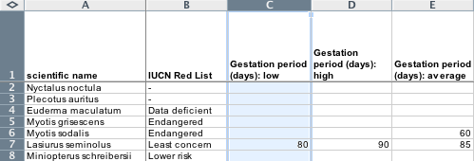

- Go to Insert (top of the screen) and choose “Column”. This puts an empty column to the right of the IUCN Red List column.

- Name the new column “IUCN codes”.

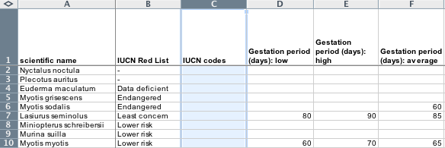

- In the IUCN codes column, enter a 1 next to values of “lower risk”, “least concern”, “no special status”, and “not evaluated” in the IUCN column. These are species that are not in conservation trouble, as far as we know. If you don’t know how to “fill down” or drag boxes to fill in a column, ask.

- Also in the new column, add a 2 next to “endangered”, “critically endangered”, “extinct in the wild”, “threatened”, “near threatened”, or “vulnerable.” These are the species that are at risk.

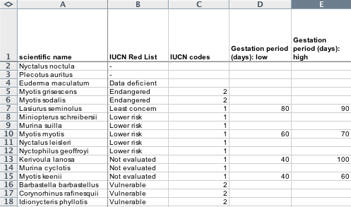

- Click on the diamond at the upper left of the spreadsheet

- Go back to Sort (under Data, at the top of the screen). Make sure that “header row” is clicked, then choose “IUCN codes” to sort on. Sort.

- You now have a list in which all species not in trouble are grouped at the top, and all species in trouble are at the bottom (if your list includes species with no IUCN category, they’ll be all the way at the bottom. Ignore them.

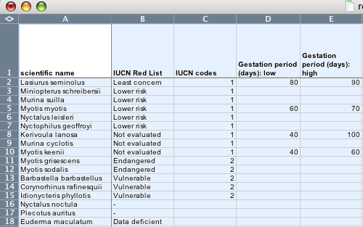

Step 2 – Look for trends by comparing species that aren’t in trouble (top bracket) with those that are (lower bracket).

