Bonus Exercise
Bird Foraging and Morphological Adaptations

As discussed during lecture, this is an opportunity for you to earn some extra credit and for me to pilot an exercise that relies on data collection from an online database rather than from a local field site. In much the same way that we assessed variation in crayfish chelipeds in Exercise Three, this exercise will test the hypothesis that beak length, beak depth, and beak shape vary among three foraging categories.

DATA COLLECTION, PART 1

The database that we will use is the Animal Diversity Web (ADW), an online natural history encyclopedia administered and hosted by the University of Michigan Museum of Zoology. The ADW has recently debuted a query tool named “Quaardvark” that can be used to retrieve datasets from the stores of information contained on the site. Quaardvark can be accessed at the following URL:

https://animaldiversity.ummz.umich.edu/quaardvark/

It is not necessary to register with the site in order to use Quaardvark, but you will be unable to save your work without registration.

Once you have navigated to the Quaardvark homepage, proceed as follows:
- Click the “Query & Report” link.
- Under the Query menu, click “Edit.” Replace “Animalia” with “Aves,” and click “Save.”
- Under the Query menu, click “Add condition.” Click “Food Habits,” click “Primary Diet,” and click the checkbox beside one of the subheadings under “Carnivore” or “Herbivore.” Click “Save Changes.”
- Under the Report menu, click “Edit,” click “Media Assets: Subjects,” click “Live Animal,” click the “Live Animal” checkbox, and click “Save Changes.”
- At this point, your screen should resemble Appendix One.
- Click “Submit” to process your query.
- Choose 15 species that have a photo of the live animal that is a profile (side view of the head).
- Save the profile photos for the 15 species to a folder for later analysis. Right click (PC) or Control + click (Mac) on each profile photo, and open it enlarged in a new window or tab before saving. Title the folder with the food type, and title each image file with the name of the species for easy identification later.
- Click “Show Query Setup” and then click “Edit” beside the Food Habits bar under the Query menu. Click the checkbox beside your previous choice to delete that selection. Now, choose another subheading, and click “Save Changes.”
- Click “Submit” to process the new query.
- Repeat steps 7 – 8 for a second Food Habits category.
- Repeat steps 9 – 11 for a third Food Habits category.

DATA COLLECTION, PART 2

Now that you have 45 images, the relative sizes of the beaks of the birds need to be assessed. For this, you will need to download the free, image-analysis program ImageJ from the NIH:

http://rsbweb.nih.gov/ij/download.html

Once you have installed ImageJ, open your first bird image using the program and proceed as follows:
- Select the line tool (fifth from the left), and draw a line from the front of the beak to the back of the head (Appendix Two). Click “Analyze” on the ImageJ menu, and then click “Measure.” Record the “Length” value, which will be displayed at the far right. This value is the “Total Length.”
- Select the line tool, and draw a line from the front of the beak to the back of the beak (Appendix Three). Click “Analyze” on the ImageJ menu, and then click “Measure.” Record the “Length” value, which will be displayed at the far right. This value is the “Beak Length.”
- Select the line tool, and draw a line from the top of the beak to the bottom of the beak at its deepest point (Appendix Four). Click “Analyze” on the ImageJ menu, and then click “Measure.” Record the “Length” value, which will be displayed at the far right. This value is the “Beak Depth.”
- Repeat steps 1 – 3 for the remaining 44 images.

DATA ANALYSIS, PART 1

Once beak measurements have been recorded from all of your images, you need to prepare an Excel file with the data. After all of the raw data are entered, you should calculate the following ratios for each species in each food type: beak length:total length, beak depth:total length, and beak length:beak depth. The first two ratios will be less than one and will need to be arcsine transformed before further analysis. Recall that this means you calculate the square root of the ratio and then calculate the arcsine of that value. Appendix Five illustrates the headings for the Excel file.

Once all of the ratio and transformation calculations have been made, the data need to be prepared for SAS analysis. Create a new Excel file with three tabs, one for each of the ratios calculated above. For each sheet, there will be two columns: food type and ratio. Copy and paste the values from the first Excel file to create these worksheets. In order to copy and paste calculated values, use the “Edit” menu, with the “paste special” command with “values” selected.

DATA ANALYSIS, PART 2

Once the second Excel file is complete, the data in each of the three worksheets can be subjected to Analysis of Variance (ANOVA) via SAS 9.2. The arcsine transformed beak length: total length ratio will determine if there is a difference in beak length among foraging categories. The arcsine transformed beak depth:total length ratio will determine if there is a difference in beak depth among foraging categories. Finally, the beak length:beak depth ratio will determine if there is a difference in two-dimensional beak shape among foraging categories.

PRESENTATION

You should submit electronic copies of your two Excel files and both electronic and hard copies of a Word document that has the following elements:

Results
- A short paragraph in which the results of the three ANOVAs and post hoc tests are presented.

Discussion
- A brief discussion (one paragraph) that describes the trends seen among food types in terms of beak length, beak depth, and beak shape.

Tables and Figures
- A table with the Primary Diets as column headings and the species names for your 15 species under each heading.
- A figure illustrating the mean, non-transformed ratios of beak length to total length for your three food types (+ SEM).
- A figure illustrating the mean, non-transformed ratios of beak depth to total length for your three food types (+ SEM).
- A figure illustrating the mean ratios of beak length to beak depth for your three food types (+ SEM).

POST MORTEM

The hard copy will be due at the beginning of lecture on 29 March 2013, and the electronic copy should be submitted before the beginning of lecture. After completing the exercise but before submitting the exercise, you must complete the student Quaardvark survey in order to receive credit for the exercise. The URL for the survey is as follows:

http://umichadmin.qualtrics.com/SE/?SID=SV_3ELd3nrWbXDFdOJ

SCORING

You can earn a maximum of 0.5 percentage points through the completion of the exercise. If you (1) produce a document that contains description and illustration of your results in accordance with the formatting guidelines of the Biology Style Manual and (2) complete the student survey, then you will receive the full bonus. Deviations from the appropriate format and/or incompleteness will result in a lower bonus, including no bonus if the shortcomings are severe.

APPENDIX ONE

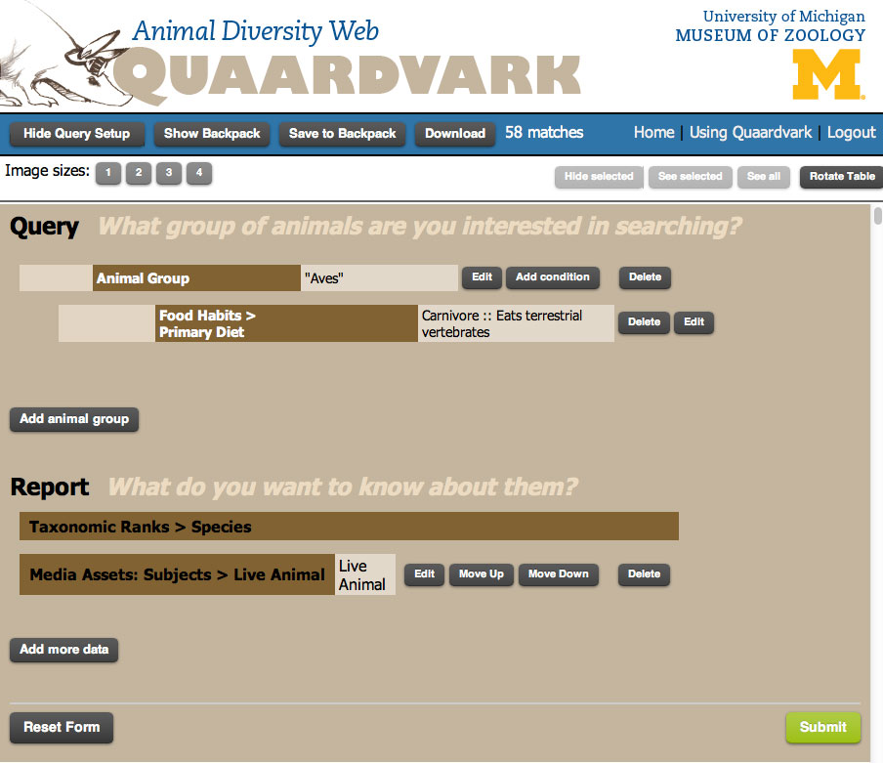

APPENDIX TWO

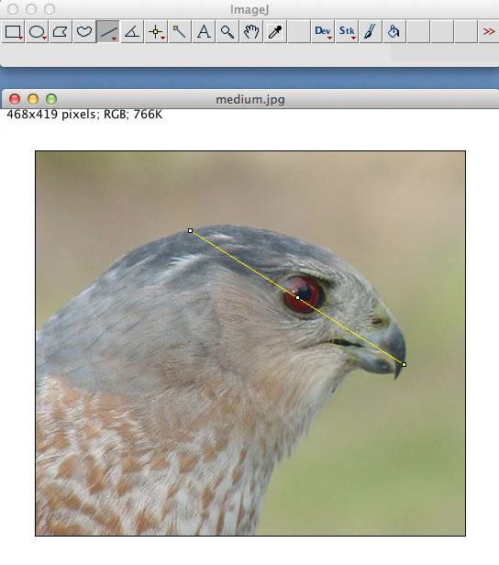

APPENDIX THREE

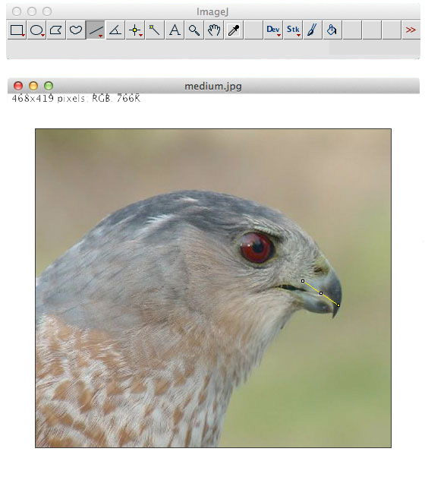

APPENDIX FOUR

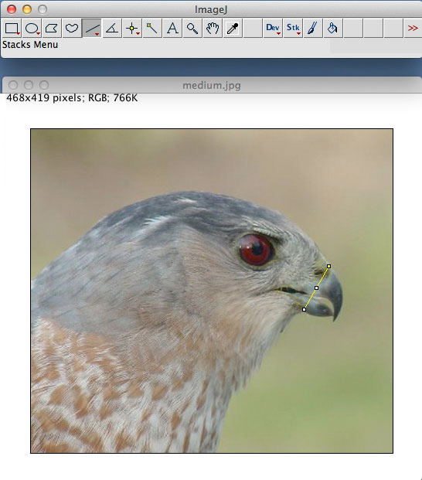

APPENDIX FIVE

